## Ai based Inventory

*by* Adeel Ahmad

**Submission date:** 29-May-2021 04:42AM (UTC-0700)

**Submission ID:** 1596596376

**File name:** AI_Based_Inventory_and_Sales_Optimizer_1.docx (2.56M)

**Word count:** 6102

**Character count:** 33961

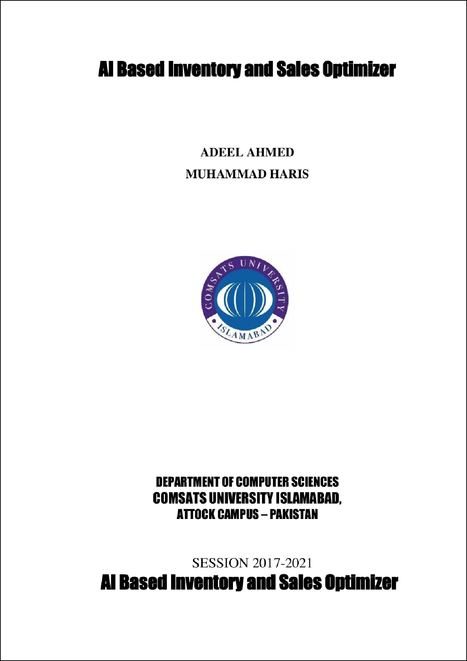

30

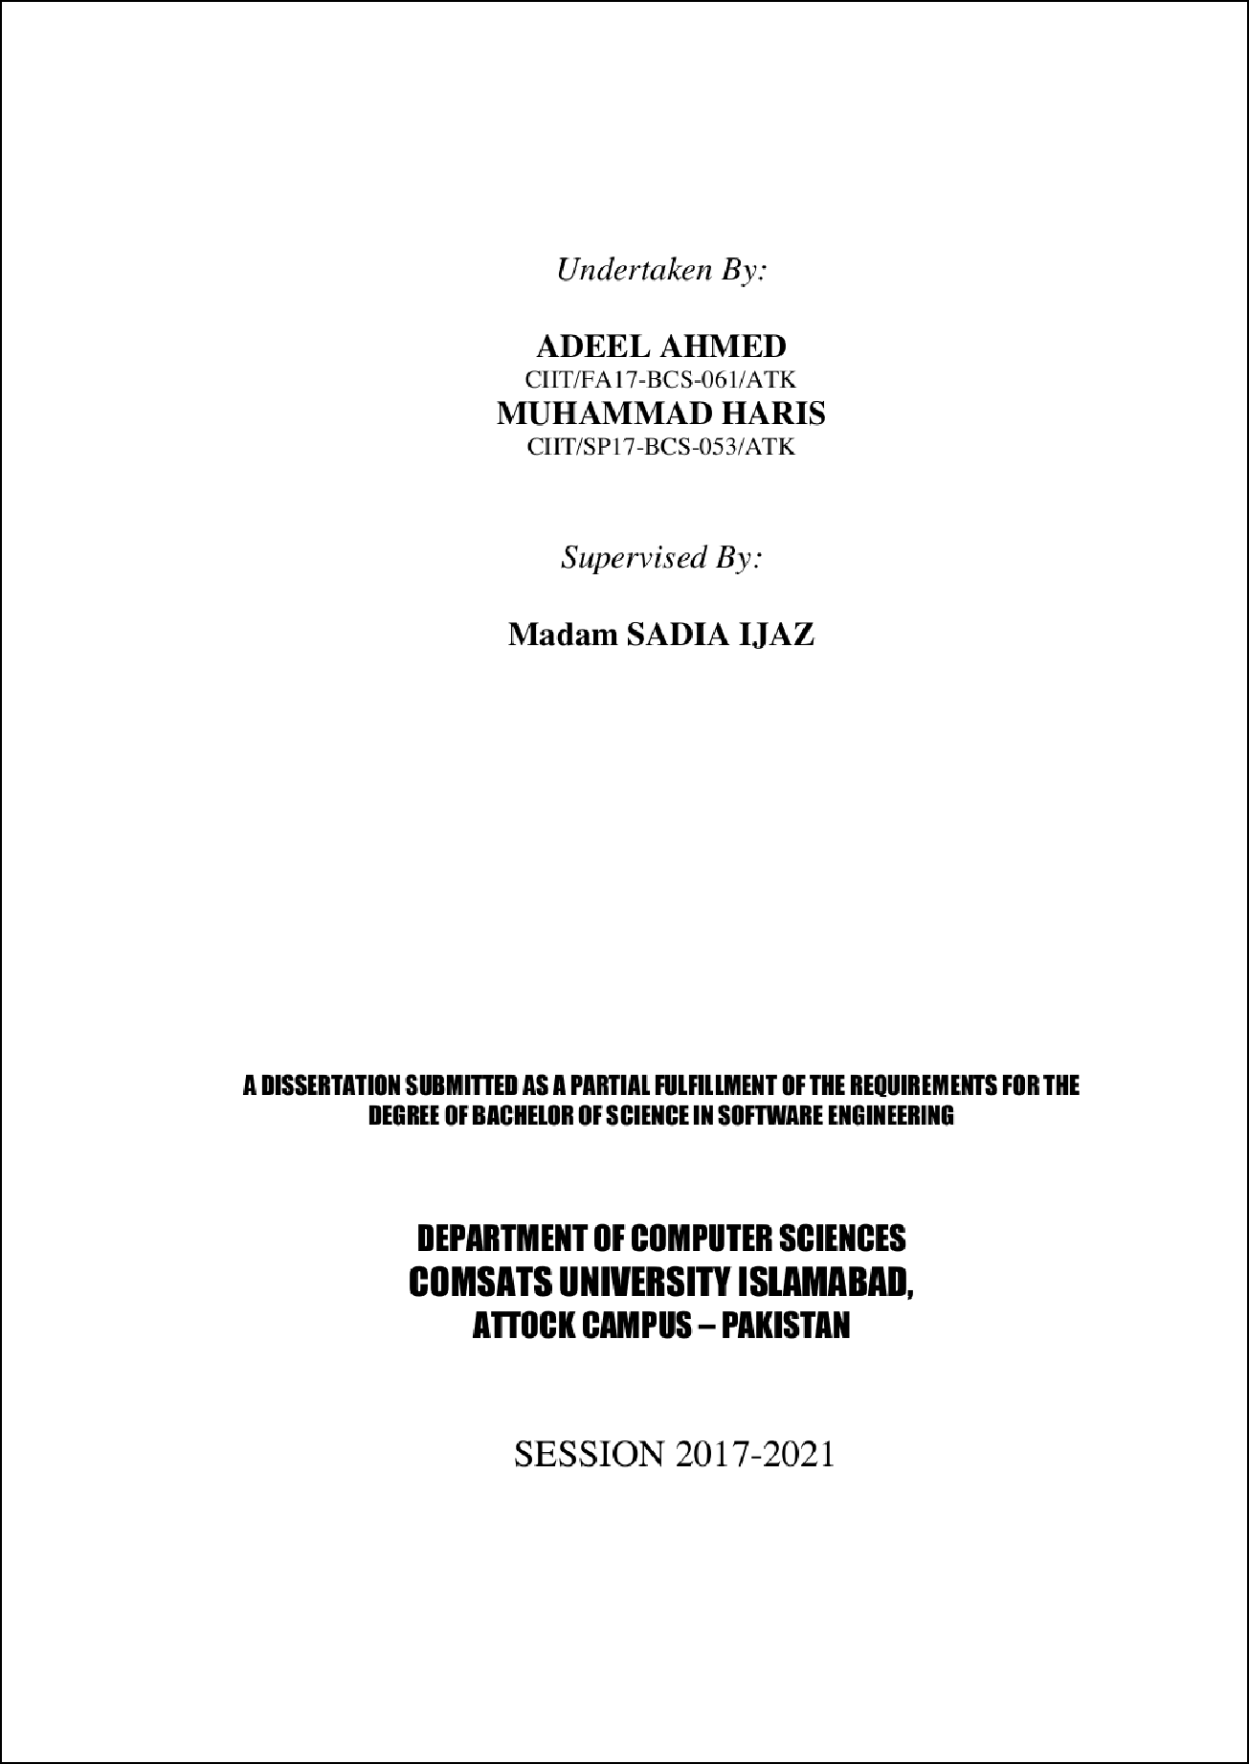

1



1



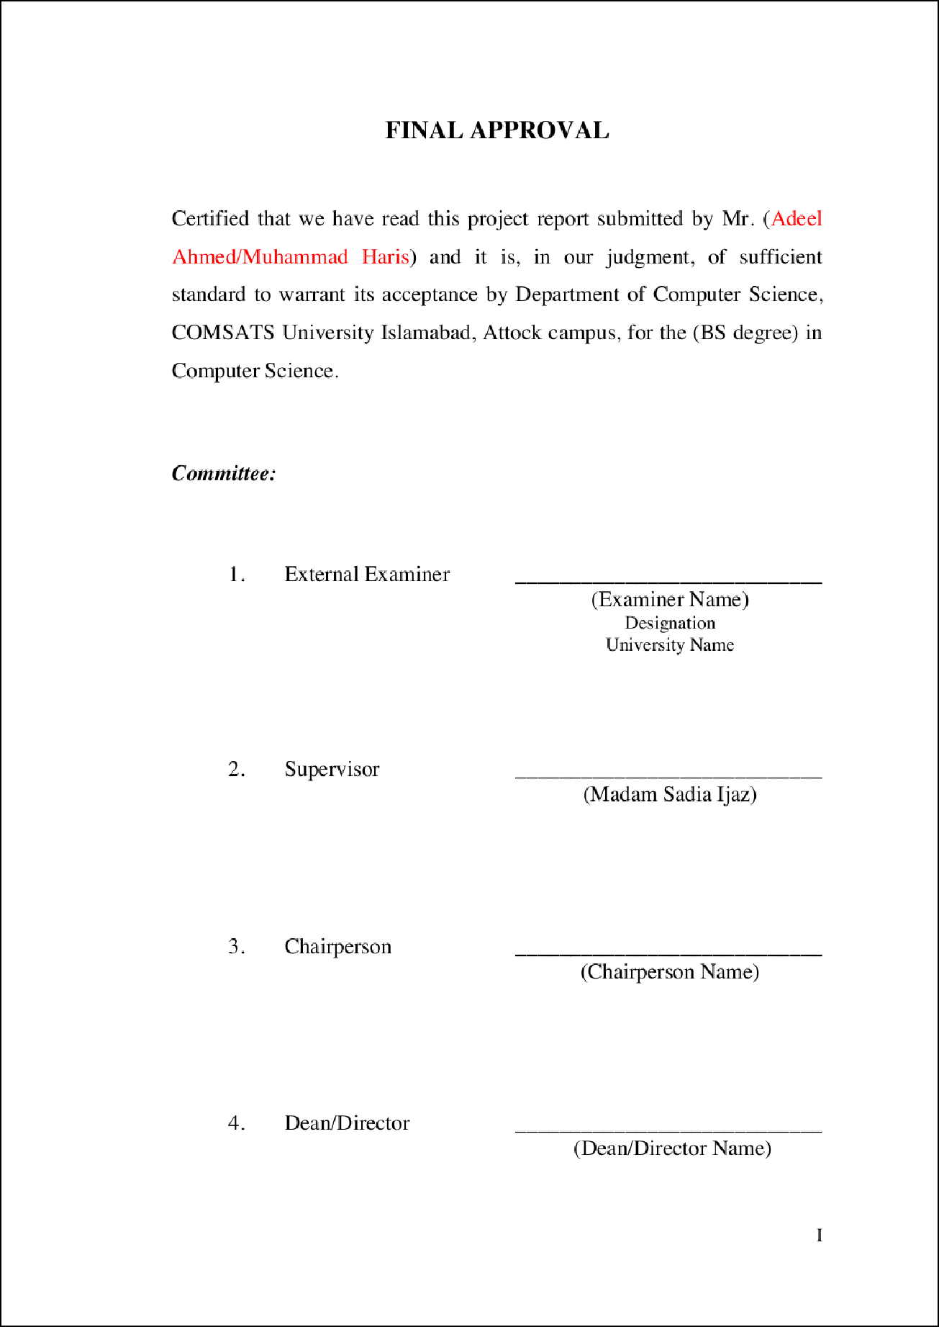

1

1

1

**DEDICATION**

Dedicated to my parents, teachers , and best friends

II



20

##### PROJECT BRIEF

PROJECT NAME

ORGANIZATION NAME

OBJECTIVE

UNDERTAKEN BY

SUPER VISED BY

STARTED ON

COMPLETED ON

COMPUTER USED

/* AI BASED INVENTORY AND SALES OPTIMIZER*/

*I* COMSATS*I*

/* TO MAINTAIN, TRACK SALES RECORD AND HELP IN OPTIMIZATION OF PRODUCTS STOCK */

/* ADEEL AHMED , Mill-lAMMAD HARIS */

/* MADAM SADIA IJAZ */

/*DESIGNATION*/

/* COMPUTER SCIENCE */

/* COMSATS UNIVERSITY ISLAMAB AD , ATTOCK CAMPUS*/

/* START DATE */

/* END DATE */

/* HP NOTEBOOK 250 04 */

IV

SOURCE LANGUAGE

OPERATING SYSTEM

/* JAVA, PHP \**I*

/* ANDROID */

TOOLS USED /* ANDROID STUDIO, MYSQL, XAMPP, SUBLIME TEXT, ADOBE ILLUSTRATOR */

V

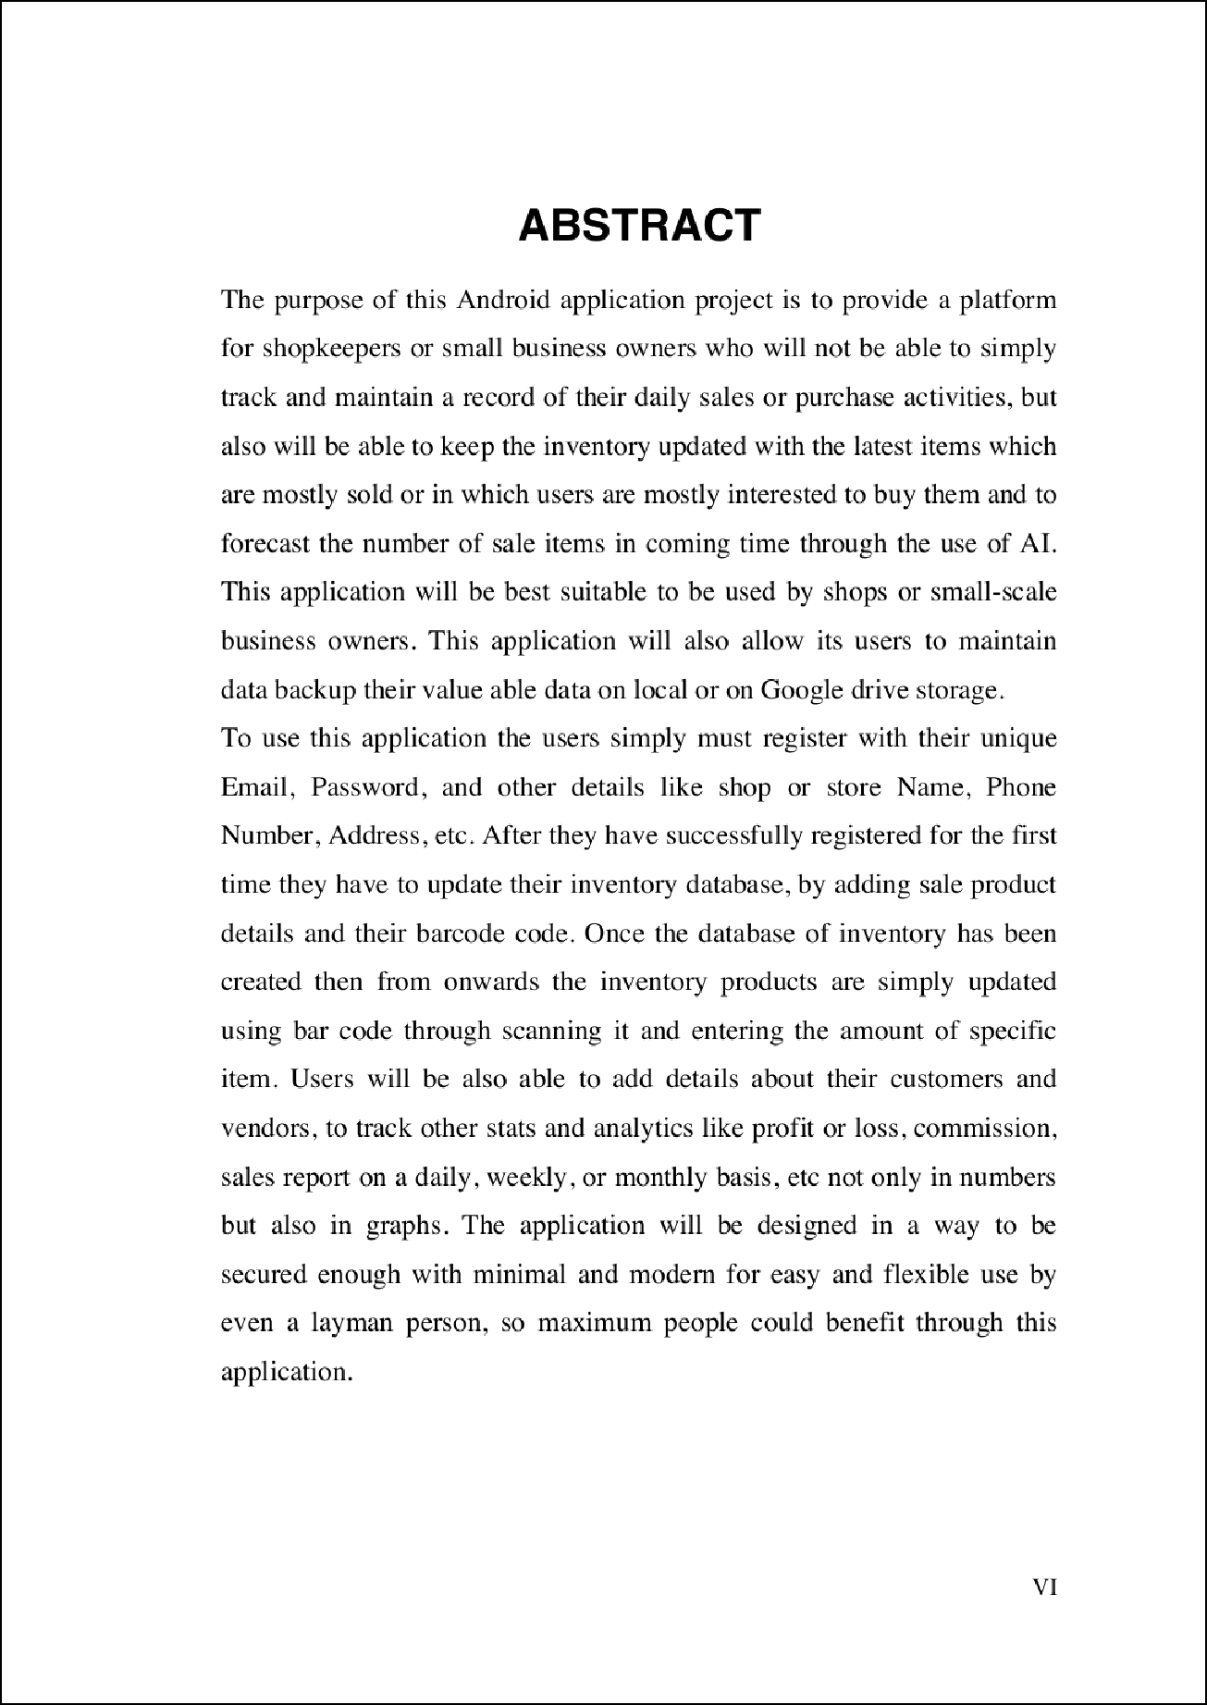

3

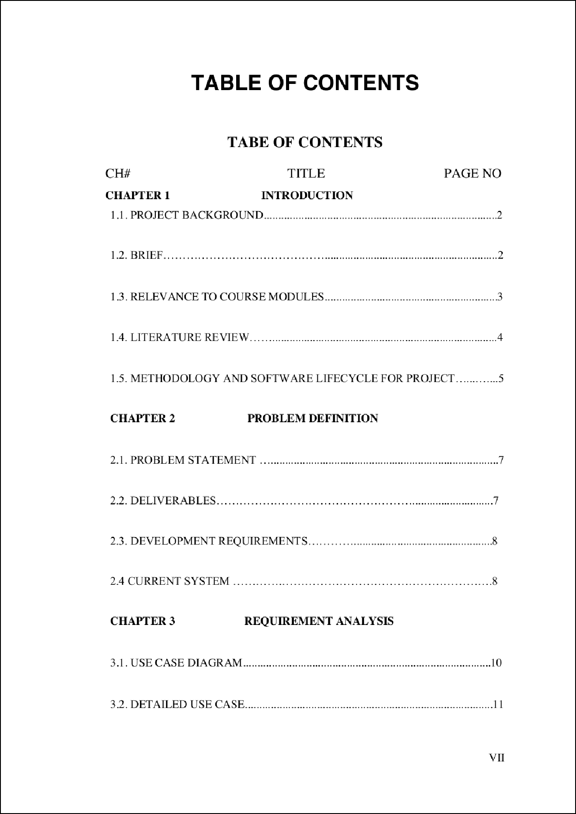

15

8

1

17

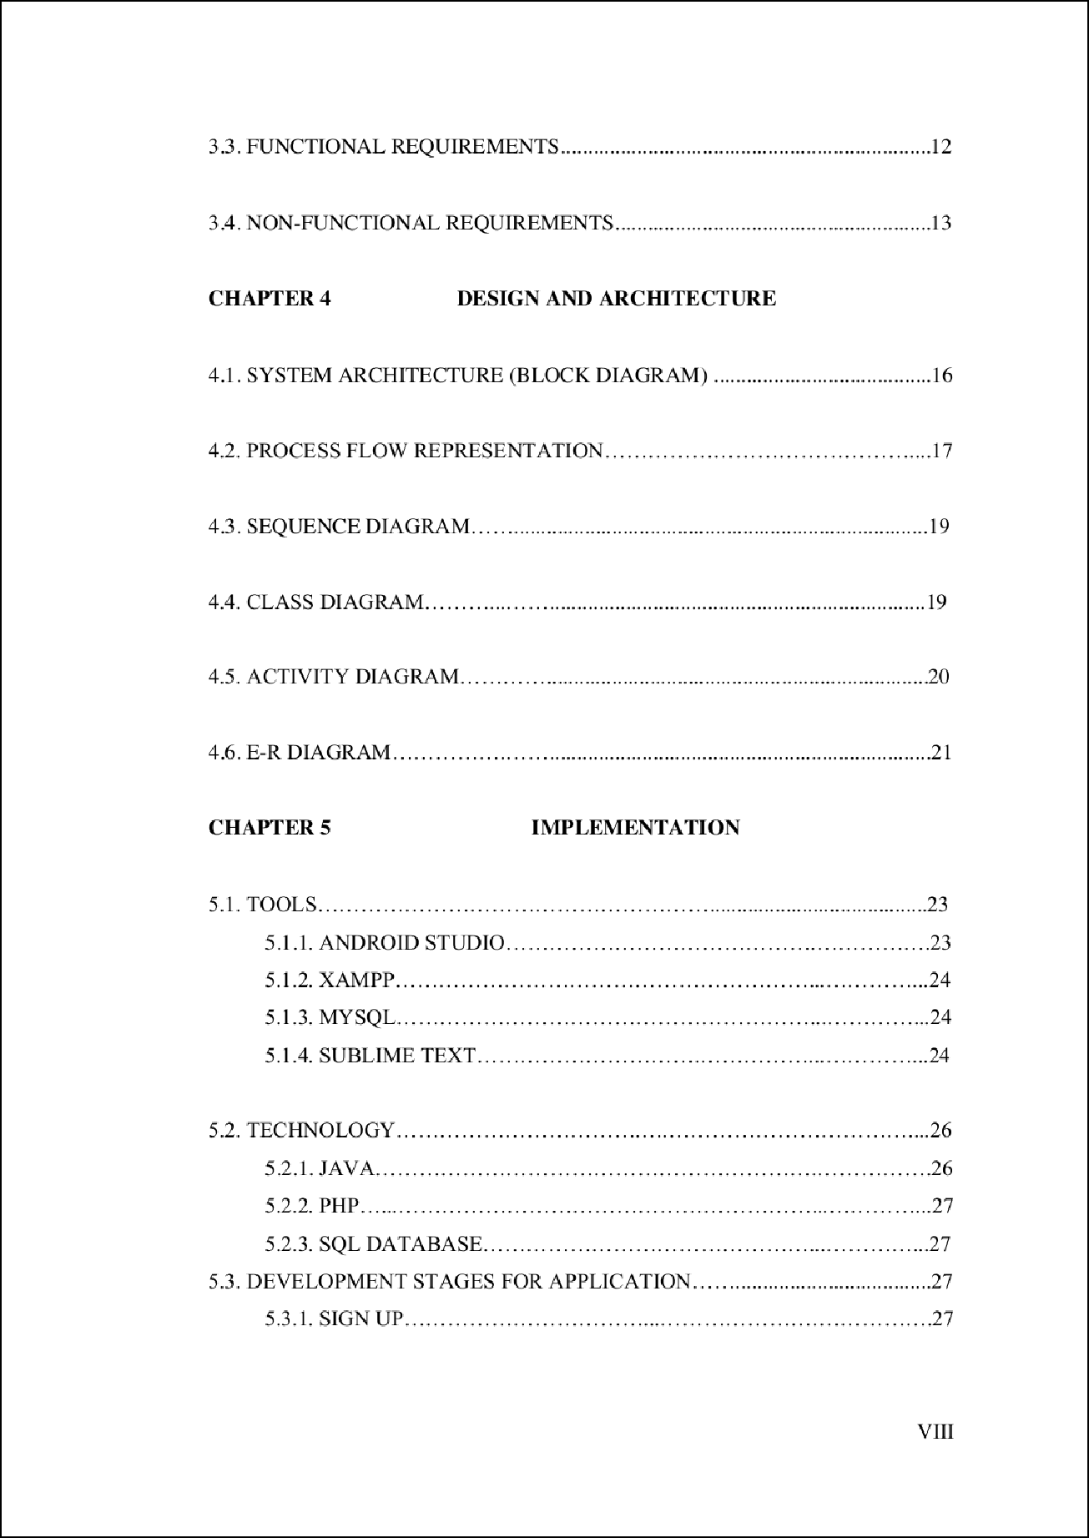

15

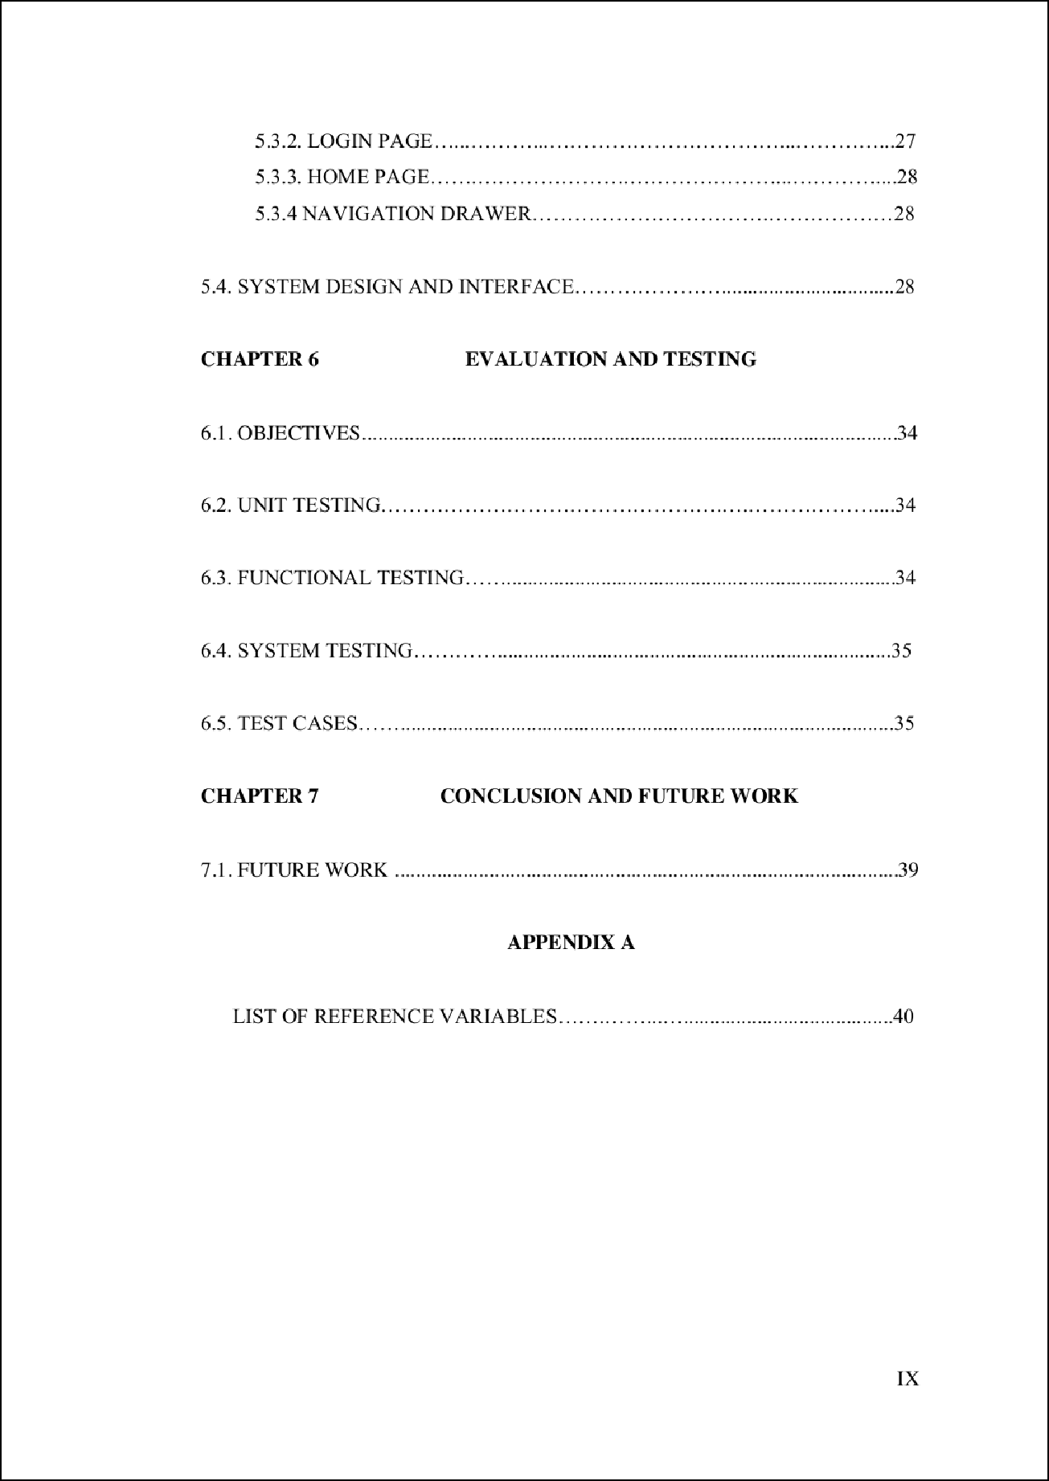

24

23

20

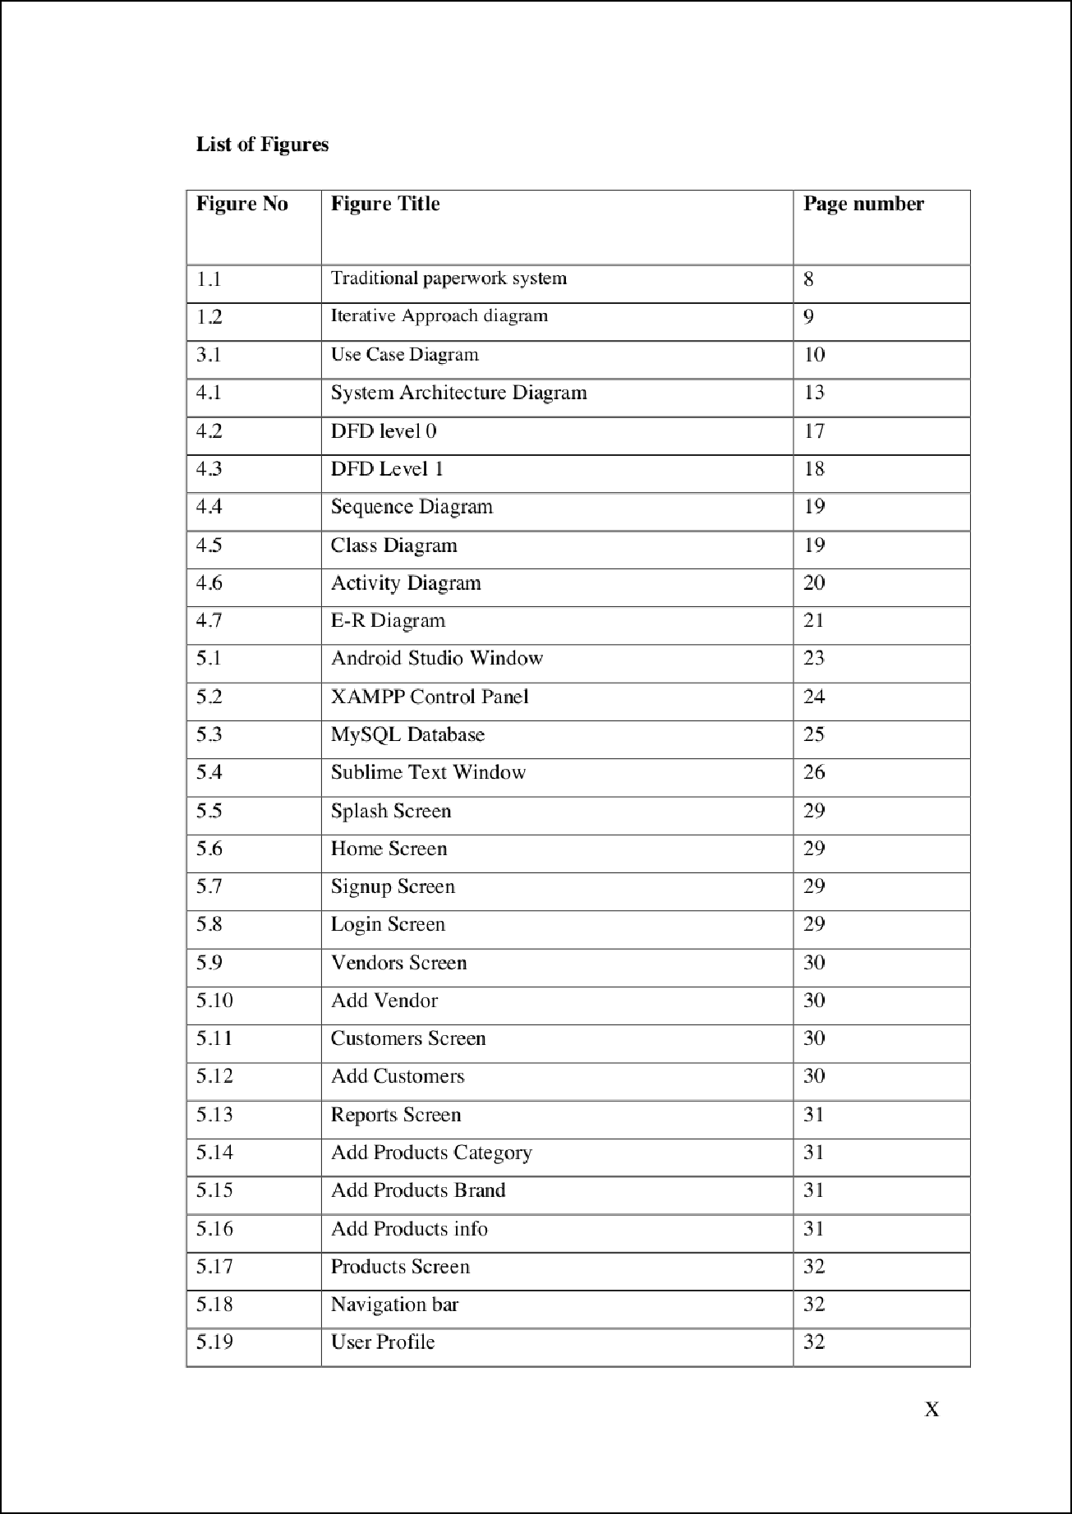

17

3

29

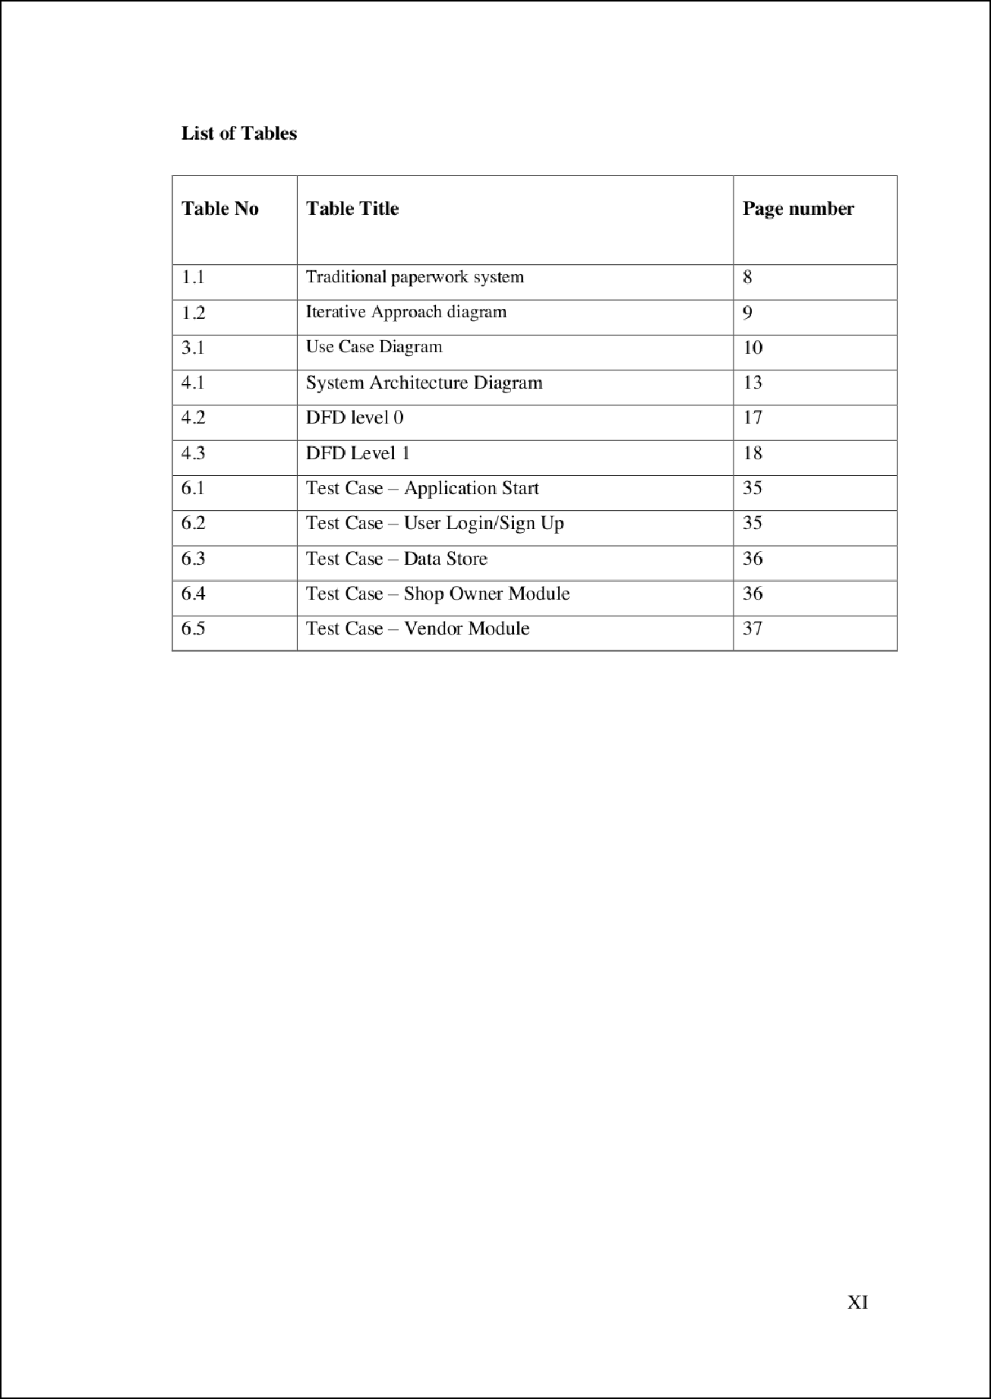

25

Chapter 1 Introduction

*1 introduction*

* 1. Project Background

The idea behind th e proposal of this app is that the trade or finance sector of any country plays an important role in its GDP from small to mega -scale. So, while keeping this thin g in our mind we decided to deve lop an app that will not only assist the business or shop owners to track and main tain the data of their busine ss produc ts or stock but will also perform some smart operation like giving useful s uggestions abou t most sellin g product s and making future sale s pred ic tions of different produc ts based on the previous data. So, based on these suggestions shop owners wi ll be able to keep the ir stock u pdated for future product sales to enhance their business.

This app will replace the manual or tr aditional paperwork system of mai ntaining and trackin g data about sale products. So ultimatel y it will assist shop or bus in ess owners to get rid of paperwork expenses and will also help to save the ir time as compared to a manu al paperwor k system.

**Figure 1.1 Traditional papenvork system**

* 1. **Brief**

In this overa ll process, we are mainta i ni ng our database and tracking our stock product s by simply ins tallin g this app on our android smartp hone. So, the very fir st ste p in this whole proves will be that the user is first asked to register or signu p by providing the required de tail s like name, email, phone, password, etc. and afterward, he can log in using these c reden tials. Now the user will e nter the product details of his

AI Base d In ventory and Sa les Op tim izer 2

*1 introduction*

stock like the product name, category, id, image , purchase price , sale price , quan tity, barcod e and can customize these details according to his choic e. So, for the very first time, the user will have to manually crea te a database and its entries, but late r he can simply scan a barcode of any item from his smartph one us ing this app to u pdate its details in inventory. T his unique fea ture of barcode scanning will help to save a lot of time for shop or busi ness owners while purchasing and sell in g any i tem.

Afterward, there will be another section of vendors and customers where users will be also ab le to add the details about them like their Name, Phone number, address, etc . and these details will be used while buying any item from a vendor or selling any ite m to his cus tomers.

Another usefu l option in this app is tracking stats and transactions whic h the user can filter out on a daily, weekly, or monthly basis . T hrough this fea ture, users will be able to check how many produc ts are sold and purch ased and what is the amount and reven ue generated or spent through them respect ively . Moreover, the user will be also able to check profit or loss made through any item on a different t.ime basis.

To remain updated or to be aware of any product quanti ty in stock is very i mportant to keep the business in a runni ng state. So, there will be an option of "Check Status" th rough which user can check shortlisted item whic h is below specific quantity and their stock needs to be updated. Through this fea ture, the user will be able to check in ven tory status and remain updated in real-time just on a button click i nstead of manu all y checking each item.

The most uni que and core fea ture behi nd the development of this app is not onl y to track the sale s items and business stats bu t in stead it's the use of AI and data mining to optimize and predict the sale items by any shop or business owner to keep their in ven tory u pdated. So, through analyzing the trend that which product is currently most sold , or produc ts which are usually purch ased with othe r ite ms and in which users are most interested we can achieve our goal.

* 1. Relevance to Course Modules
     1. Machine Learning

In this course, we stud ie d different machine or model trainin g algorithms like "Neura l Network " which will be used to perform sales forecasting usi ng current data of the user.

AI Base d In ventory and Sales Optim izer *3*

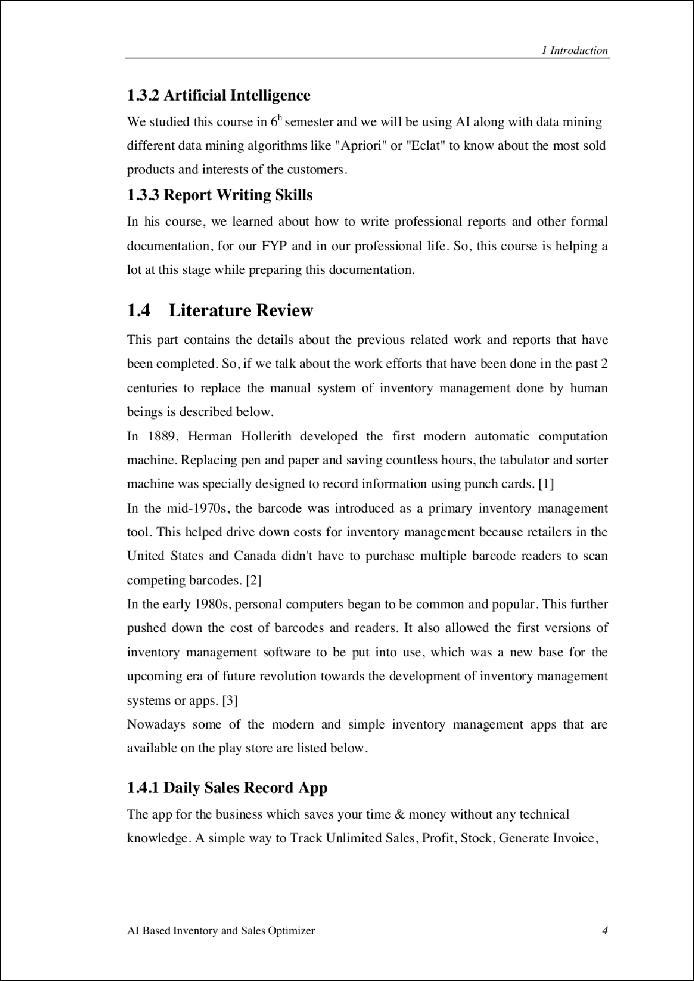

12

4

4

6

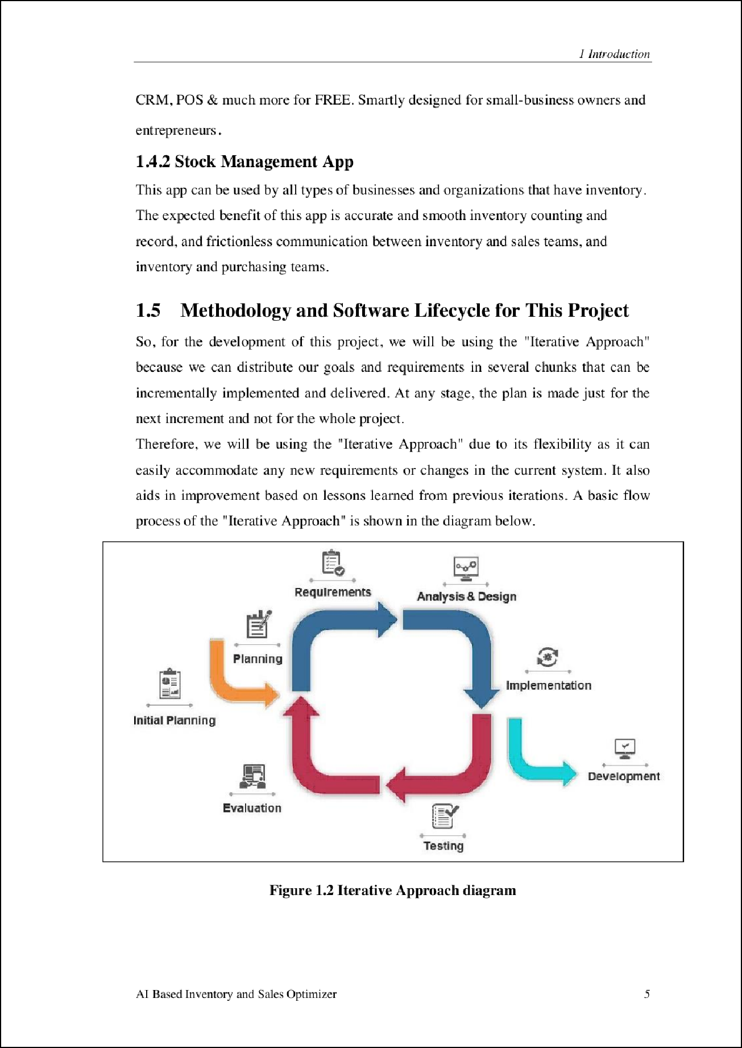

11

8

###### Chapter 2 Problem Definition

6

2 *Probl em Definition*

1. Problem Definition

The main aim of our project is to automate the manual operation of inventory management and also provide the sale s predic tions and useful sugge stions about the mo st sell in g products to maintain the stock u pdated for future sales.

* 1. Problem Statement

As techn ology evolution is gettin g fast day by day so people are getting more dependent on techn ology. Tec hnology is almost impacting every aspect of our life so, on behalf of this approach we decided to develop an ap p to assist shop or small warehouse owners to facilitate them from their smartphones. While proposing thi s idea we kept in our mind tha t these people usua ll y cannot afford a computer operator or hire an accountant who will be responsible to maintain the records of sales and inventory to run the business succe ssfu lly. So, in this aspect, this free app will provide major benefits to them by savin g thei r time and money. Not only this but it will also help to optimize their sales and keep the inventory updated with the most selling product s.

* 1. Deliverables
     1. Mobile based application interface:

A responsive and meaningful mob ile-based appl ic ation interface for android devices that will allow the user to explore through the application in their perspective and u l timate l y will provide easiness and comfort to them.

* + 1. Inventory setup:

Here users will ha ve to enter the products detail which are currently present in his inventory and can customize them in different categories based on his own choice.

2.23 Image and barcode uploading:

The users will be able to u pload images of differe nt products in their inventory li s t and their barcodes also if they are ava ilable.

* + 1. Barcode scanner:

The barcode uploaded by the user of any specific product can be used later to update its details in inventory later onwards by simp l y scanning it through the app which will save a lot of time.

* + 1. Product sale prediction and optimization:

AJ Based Invent ory and Sales Optimize 7

2 *Probl em Definitio n*

This section is abo ut the sugges tion and sales provided by Al and data mmmg algorithms by ana l yzing the previous sale s records of any user to help in optimi zing his sales and maintain the stock of produc ts in invent ory.

* + 1. User data export and backup:

This section is about saving the previous value able data of the user. So, to preserve it we will be creating a local backup or a google dr ive backup.

* 1. Development Requirements

Fo llowin g are the req uireme nts which must be fulfilled by the user to run this app smoothl y on his and roid smartphone.

* + 1. OS requirement

Smartphone with Android OS 4 or above than this.

* + 1. **Software requirements** IDE: Android Studio, IDLE or PyCharrn Programming Lang uage: Java, Python
    2. Other tools

For designing app graphic s, we will use Adobe Illustrator.

For making documentation we used Word. And for presentation we used PowerPoint.

* 1. Current System

Followin g are the related feat ures of our sys tem in running state whic h is successfully tested.

The system can

* + - * Allows the registration of the use r with the required details.
      * The user can log in and logout of the syste m using his credentials.
      * The system also allows the user to enter the product details and upload its image and barcode.
      * Users can view the products entered into their database.
      * The system also allows the user to enter the de tails of his vend ors and customers .
      * Users can customize their products based on category and brand .

AJ Based Invent ory and Sa les Optimize *8*

###### Chapter 3 Requirements Analysis

*9*

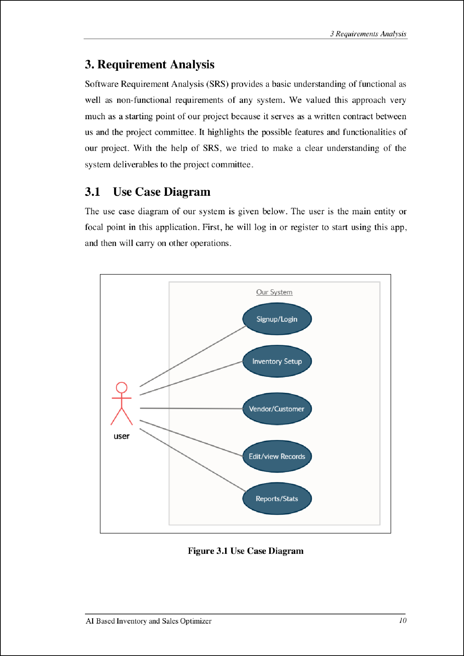

14

3

*3 Requi rements Anal ysis*

* 1. Detailed Use Case

The use cases shown in the figure above are separatel y described below wi th clear details and action take r.

* + 1. Signup/Login

**Use case name:** Signup/Login

**Action:** User

**Summary:** The user will provide the required details for the logi n or signu p process, as an initial step to use this appl ication.

**Pre-condition:** The use r mus t provide correct details while signup and use similar details to login into the system ; otherw ise he has to face errors.

**Post-condition:** Af te r signing in user can freel y explore the app to carry on other processes.

* + 1. Inventory setup

**Use case name:** Inve ntory setu p

**Action:** User

**Summary:** The user will set up his inventory database when using this app for the first time. He can enter different details about the stock produc ts and can also u pload the ir image, barcode. He can even customize his stock products in different su bcategor ies as per his choice.

**Pre-condition:** The user will enter the name. Price, image , and other simil ar details for his product s for inventory setu p.

**Post-condition:** The use r can also edit these details after ward whenever required.

3.23 Vendor/Customer

**Use case name:** Ve ndor/Customer

**Action:** User

**Summary:** The user can enter the details about his vendors and customers which will be used at the time of purchasing or selling any item.

**Pre-condition:** The user will enter the name . phone number , address, etc, and other simil ar details for his vendors and customers.

* + 1. Edit/View Record

**Use case name:** Edit/View Record

**Action:** User

AJ Based Invent ory and Sales Optimizer *ll*

*3 Requi rements Anal ysis*

**Summary:** This section contains all the details about the products, vendors, and customers. Here users can view each of them in detail and can edit, u pdate, or delete them.

**Pre-condition:** The user can view, edit, delete all the records of products, vendors, and customers he has entered before.

**Post-condition:** User can still view, perform an update, and delete operation on the current data.

* + 1. Report /Stats

**Use case name:** Report/Stats

**Action:** User

**Summary:** User can check all the business stats and reports and can get an idea about the items sold and purchased, profit and loss, etc on a daily, weekly, monthly basis.

**Pre-condition:** The user can only view the stats on a different time basis, but he can 't modify th em.

**Post-condition:** Stats and reports are generated by the system from time to time by analysing the user sales da ta.

3.3 Functional Requirements

Functional requ ire men ts are the req u iremen ts that must be present in any system to fulfill its purpose of development, and without those funct ionali tie s, a sys tem is considered worthless. So, the fu nctional requiremen ts of our system include;

* + - * Allows the user to sign up to usin g the app for the first time .
      * Users can log in to the app after registerin g them succe ssfully.
      * Add inventory products and their details.
      * Can also add im age and barcode of inventory products.
      * Customize the produc ts on basis of differen t categories and brands.
      * Add customer 's and vendor's details.
      * Update the product detail s by jus t s imply scanning its barcode from the app.
      * Review and update all the details of produc ts, vendors, and cus tomers by simp ly filtering out different factors.
      * Users can view and track all the stats and records of sales and purchase, profit, and loss on different time periods.

AJ Based Invent ory and Sa les Optimizer *12*

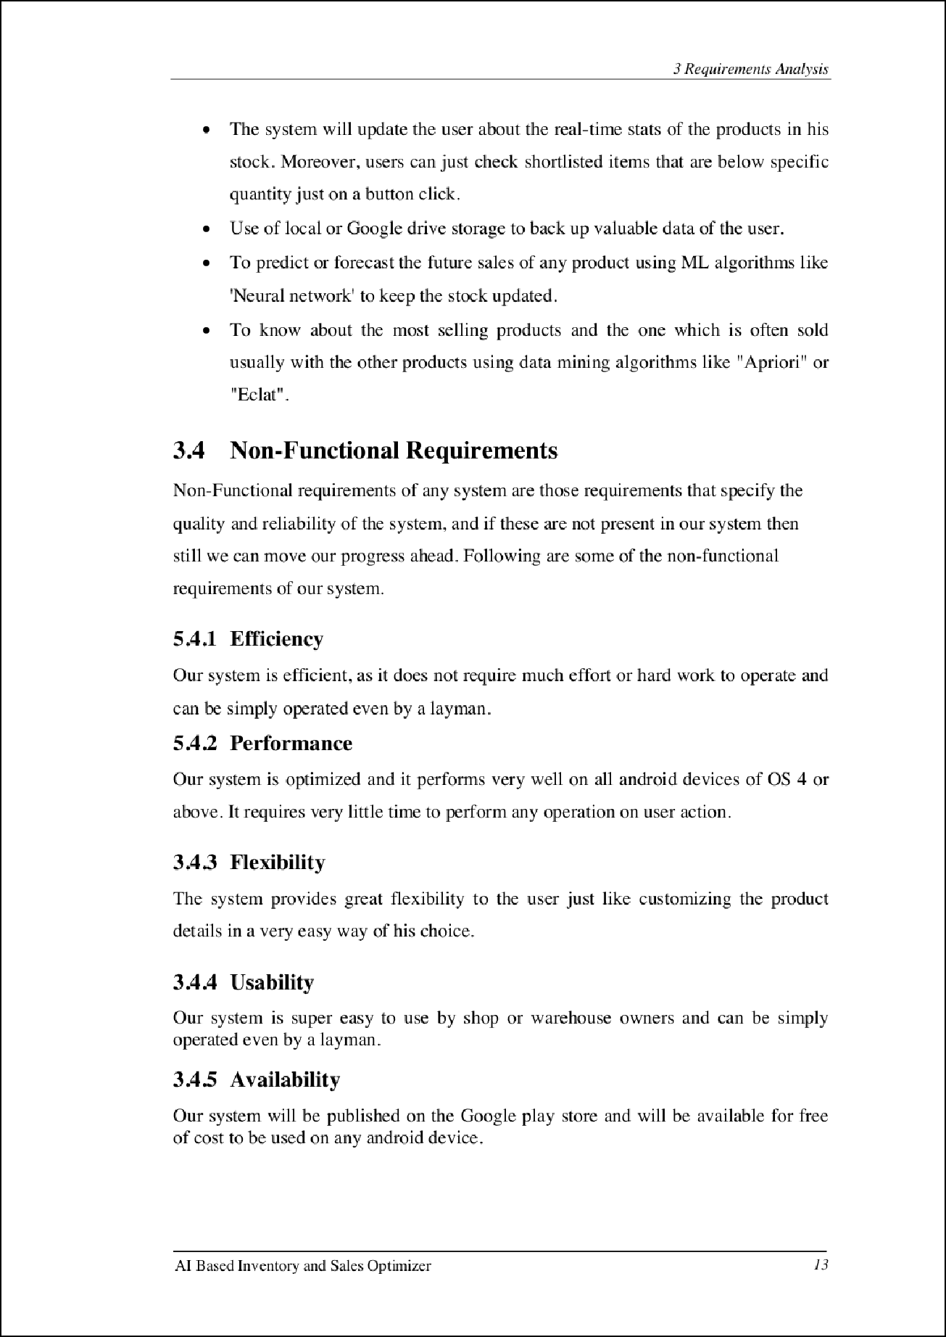

28

*3 Requi rements Anal ysis*

3.4.6 Reliabilit y

Our system is tested vanous ti me s to produce and generate 100% reliable and accurate res u l ts.

AJ Based Invent ory and Sa les Optimizer *14*

###### Chapter 4 Design and Architecture

15

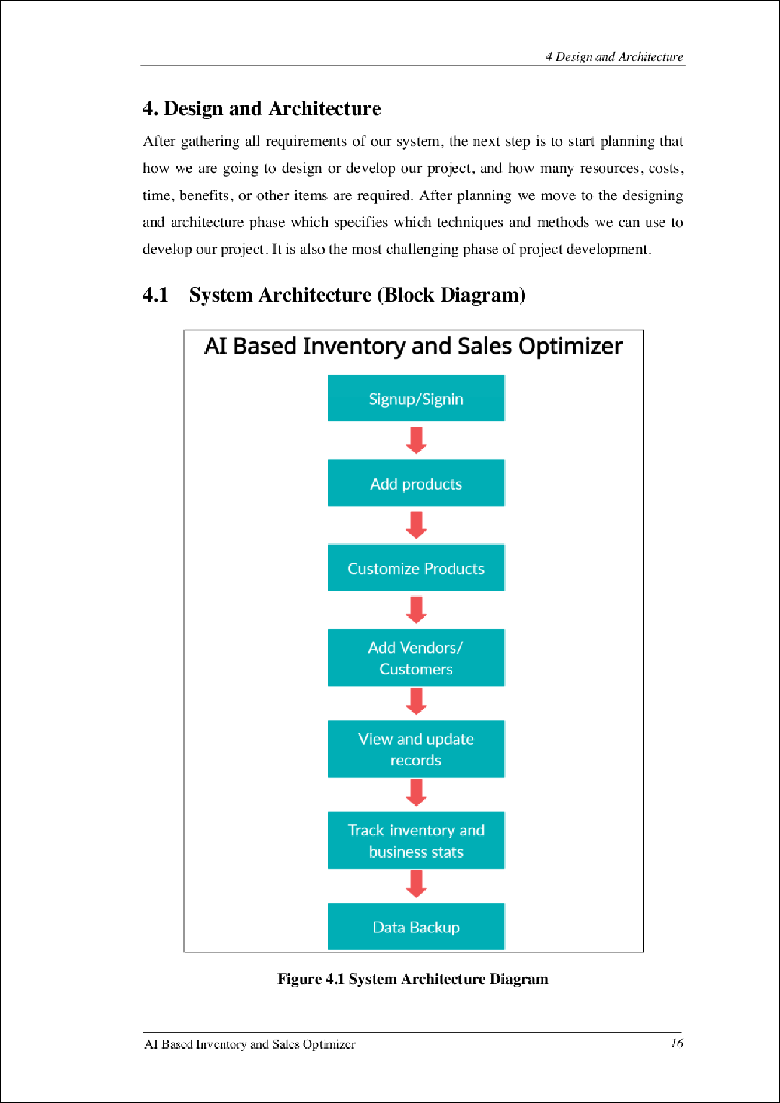

21

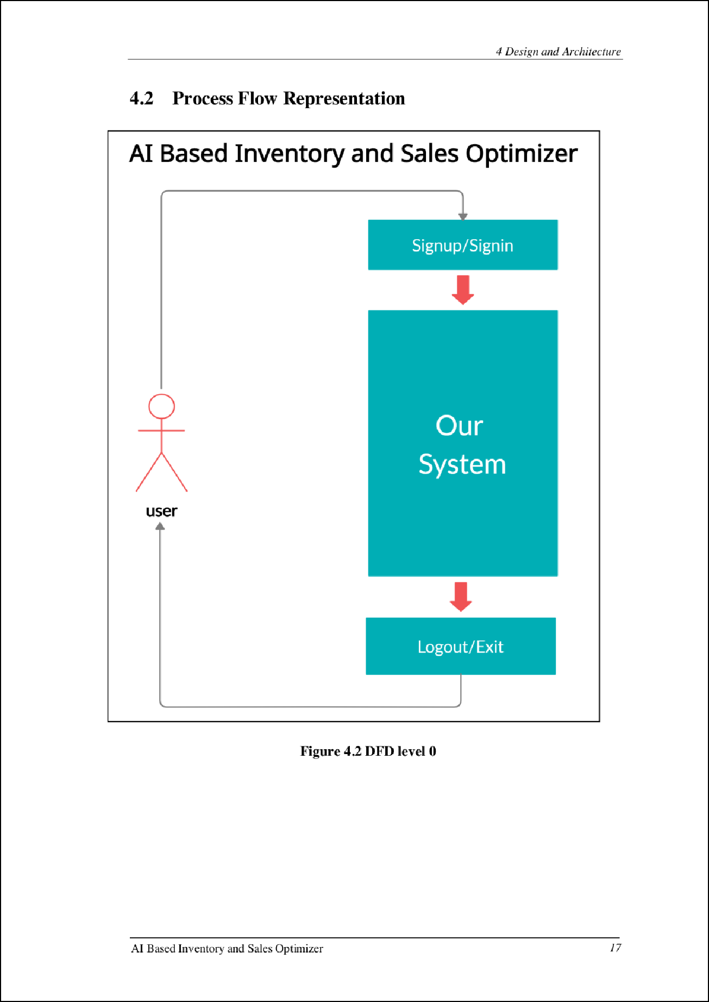

27

*4 Desig n and Architecture*

|  |  |
| --- | --- |
| **AI Based Inventory and Sales Optimizer**  Signup/Signin  Add products  Customize Products  Add Vendors/ Customers  **user** | |
|  | View and update  records  Track inventory and business stats  Data Backup  Logout/Exit |

**Figure *43* DFD Level 1**

AJ Based Invent ory and Sa les Optimizer *18*

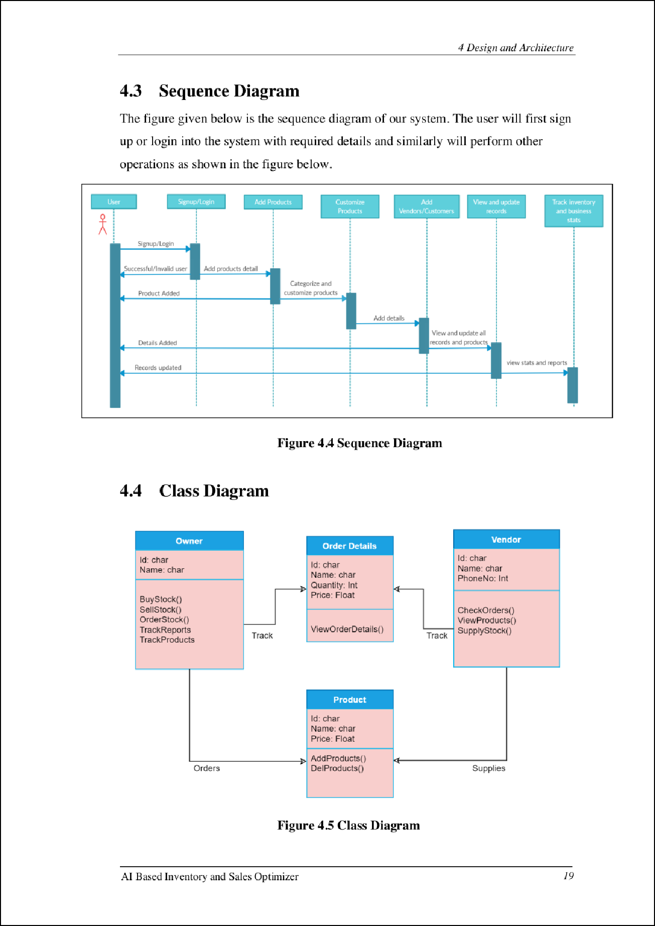

1

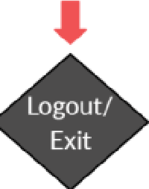

*4 Desig n and Architecture*

* 1. **Activity Diagram**

AI Based Inventor y and Sales Optimizer

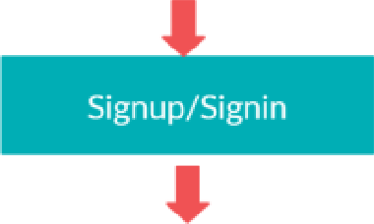user

Add products

Customize Products

Add Vendors/ Customers

View and update records

Track inventory and

business stats

Data Backup

**NO**

- **' YES**

**Figure 4.5 Activity Diagram**

AJ Based Inve ntory and Sales Optimizer *20*

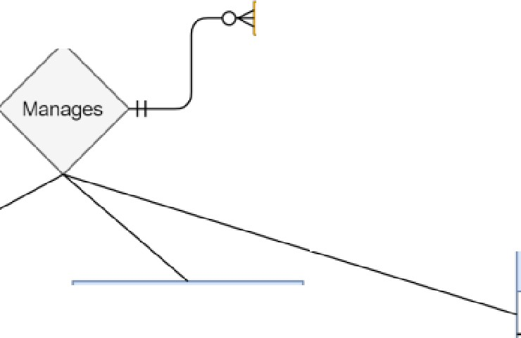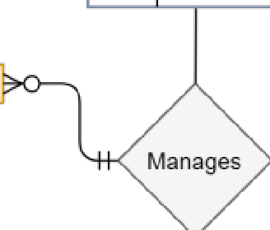

*4 Desig n and Architecture*

* 1. E-R Diagram

Email Password

**Log in**

|  |  |
| --- | --- |
| **Inventory** | |
|  | Product Id |
|  | Name Categroy Stock left |

**Owner /User**

|  |  |
| --- | --- |
| **Signup** | |
|  | Email password |
|  | Name  Shop Name Phone No. Address Currency |

|  |  |  |
| --- | --- | --- |
|  | |  |
| **Vendor/Customer** | | |
|  | CNIC | |
|  | Name Phone **No.** Address Email | |

**Product s**

If.I

|  |  |
| --- | --- |
| **Reports** | |
|  | Stats |
|  | Analyze Profits/Loss Sale items |

Name **QR** code Quantity Picture

**Fignre 4.5 E-R Diagram**

AJ Based Inve ntory and Sales Optimizer *21*

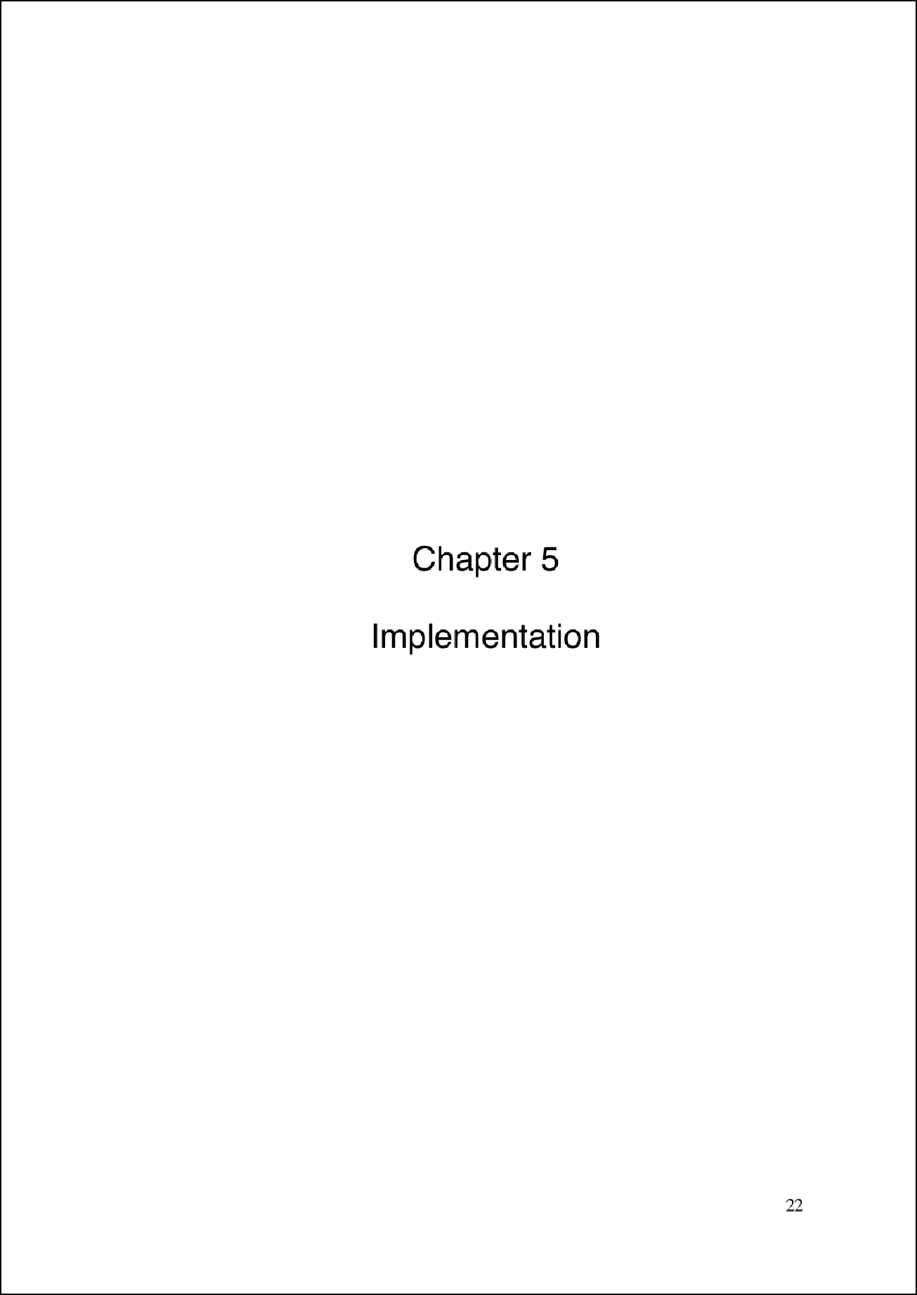

1

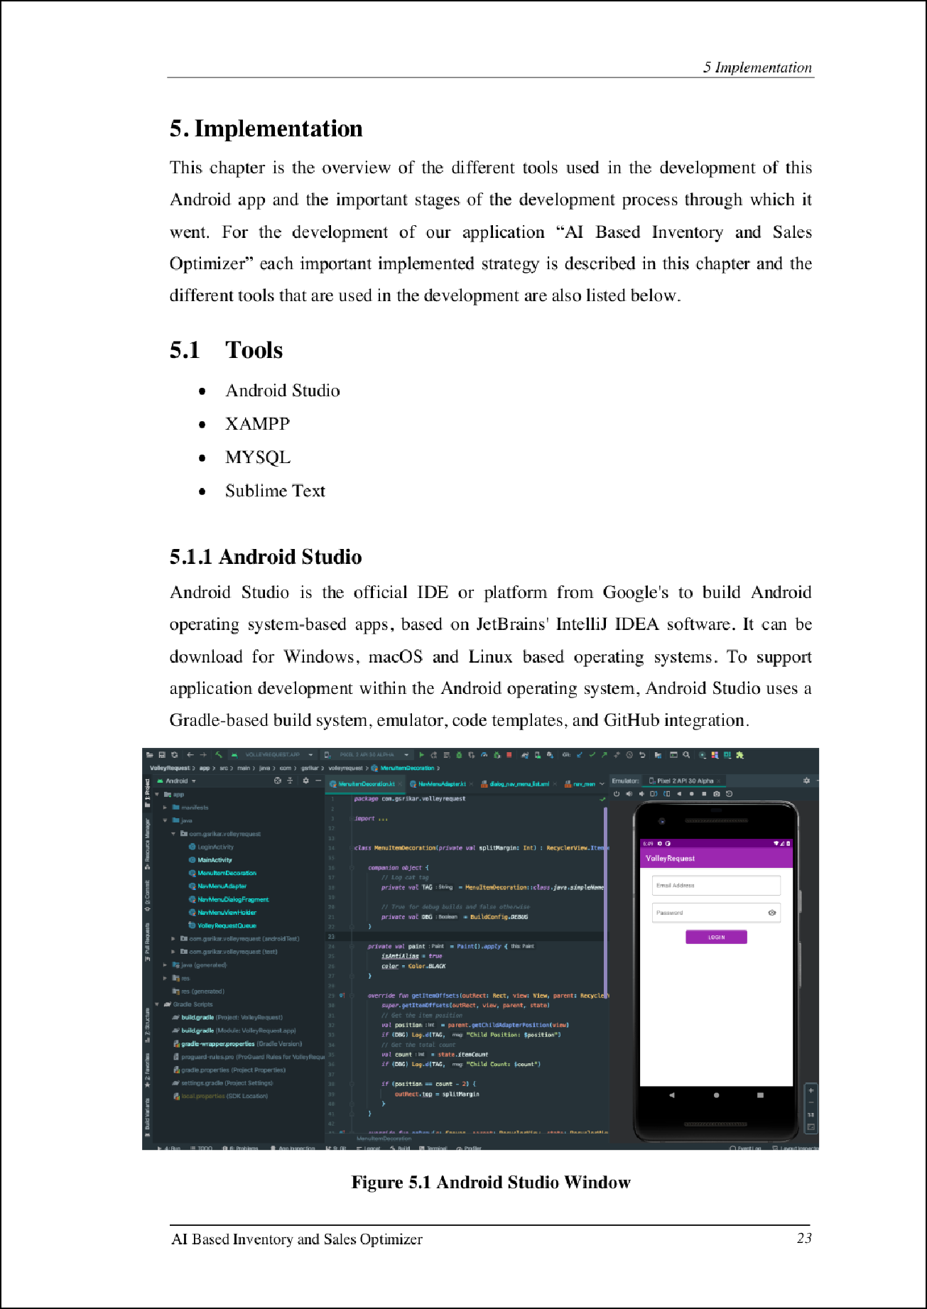

13

3

16

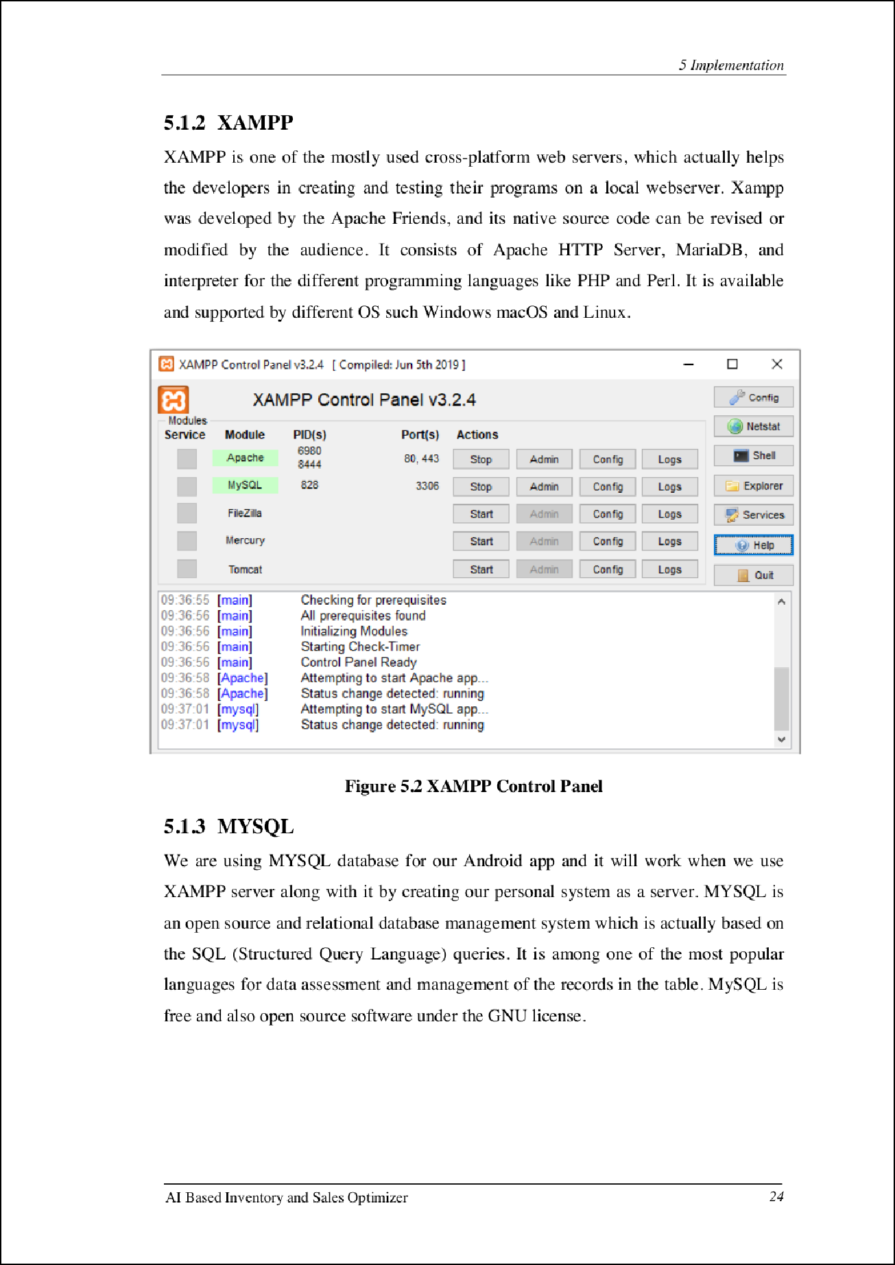

2

2

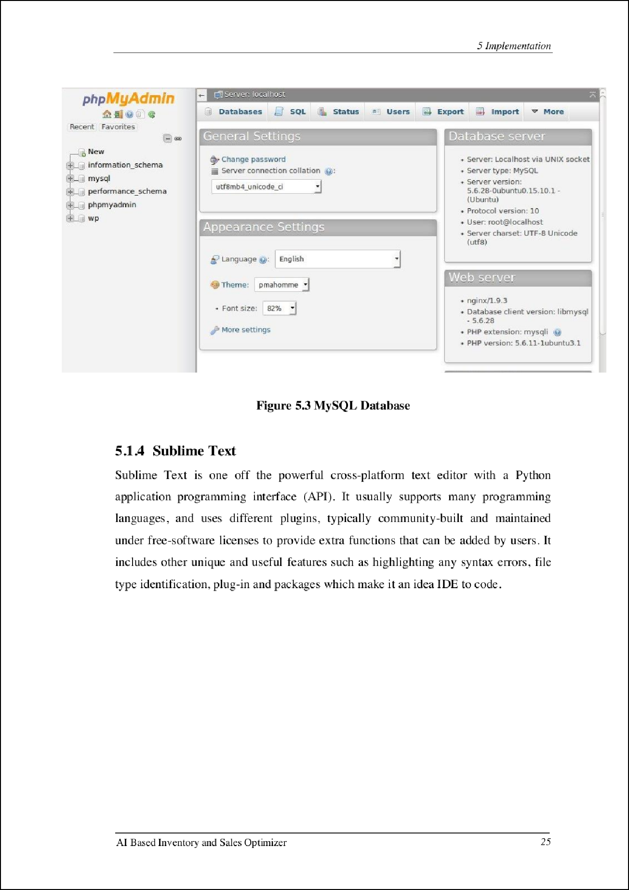

1

26

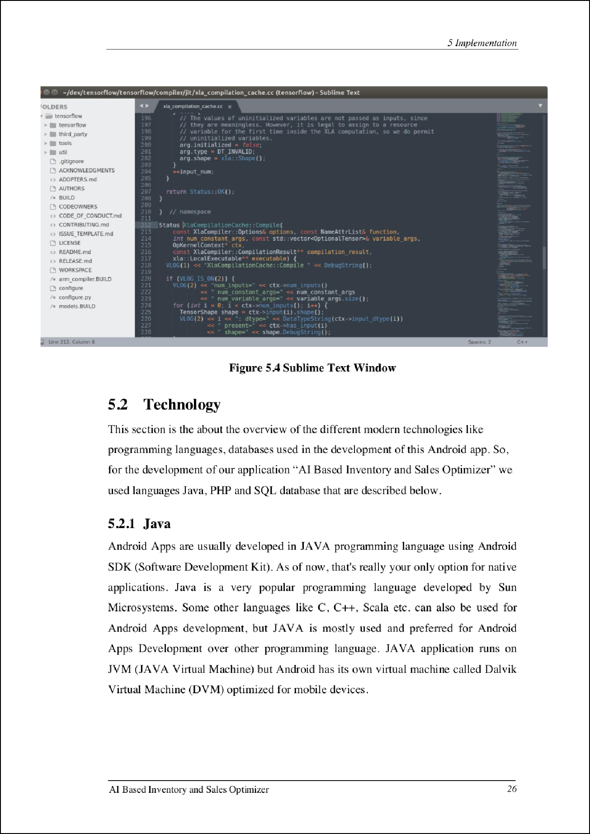

14

3

5

5

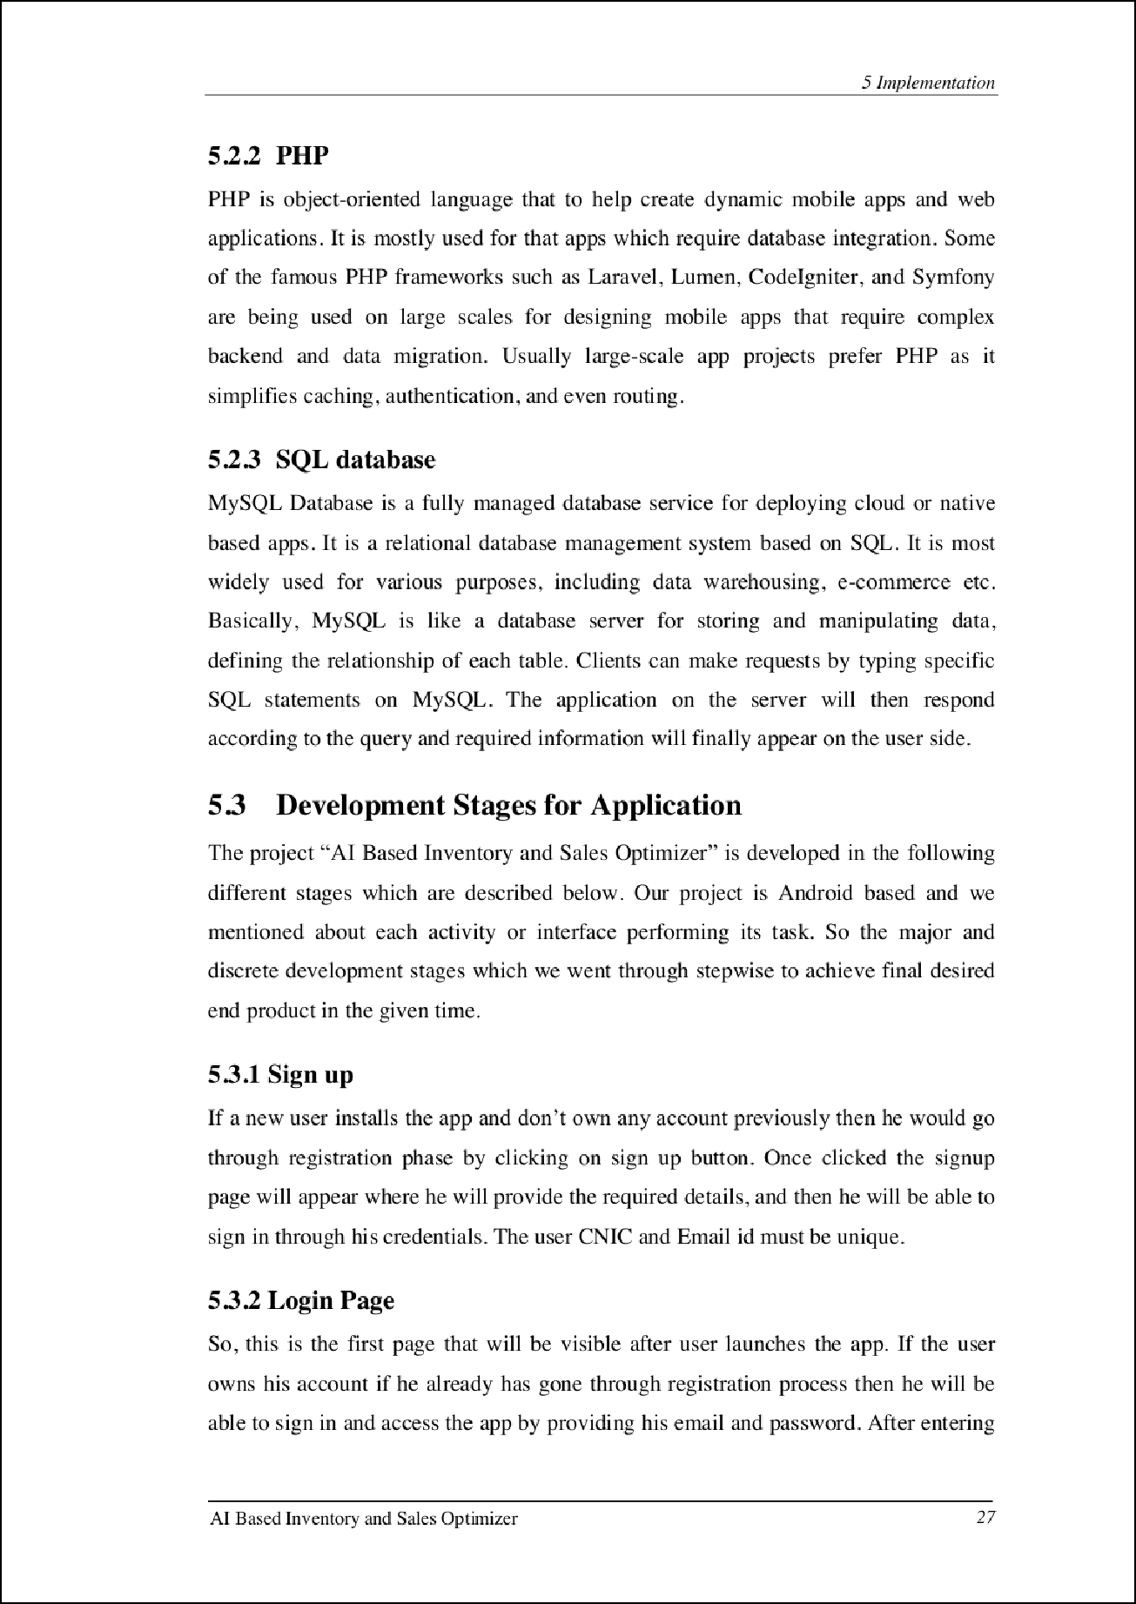

22

2

7

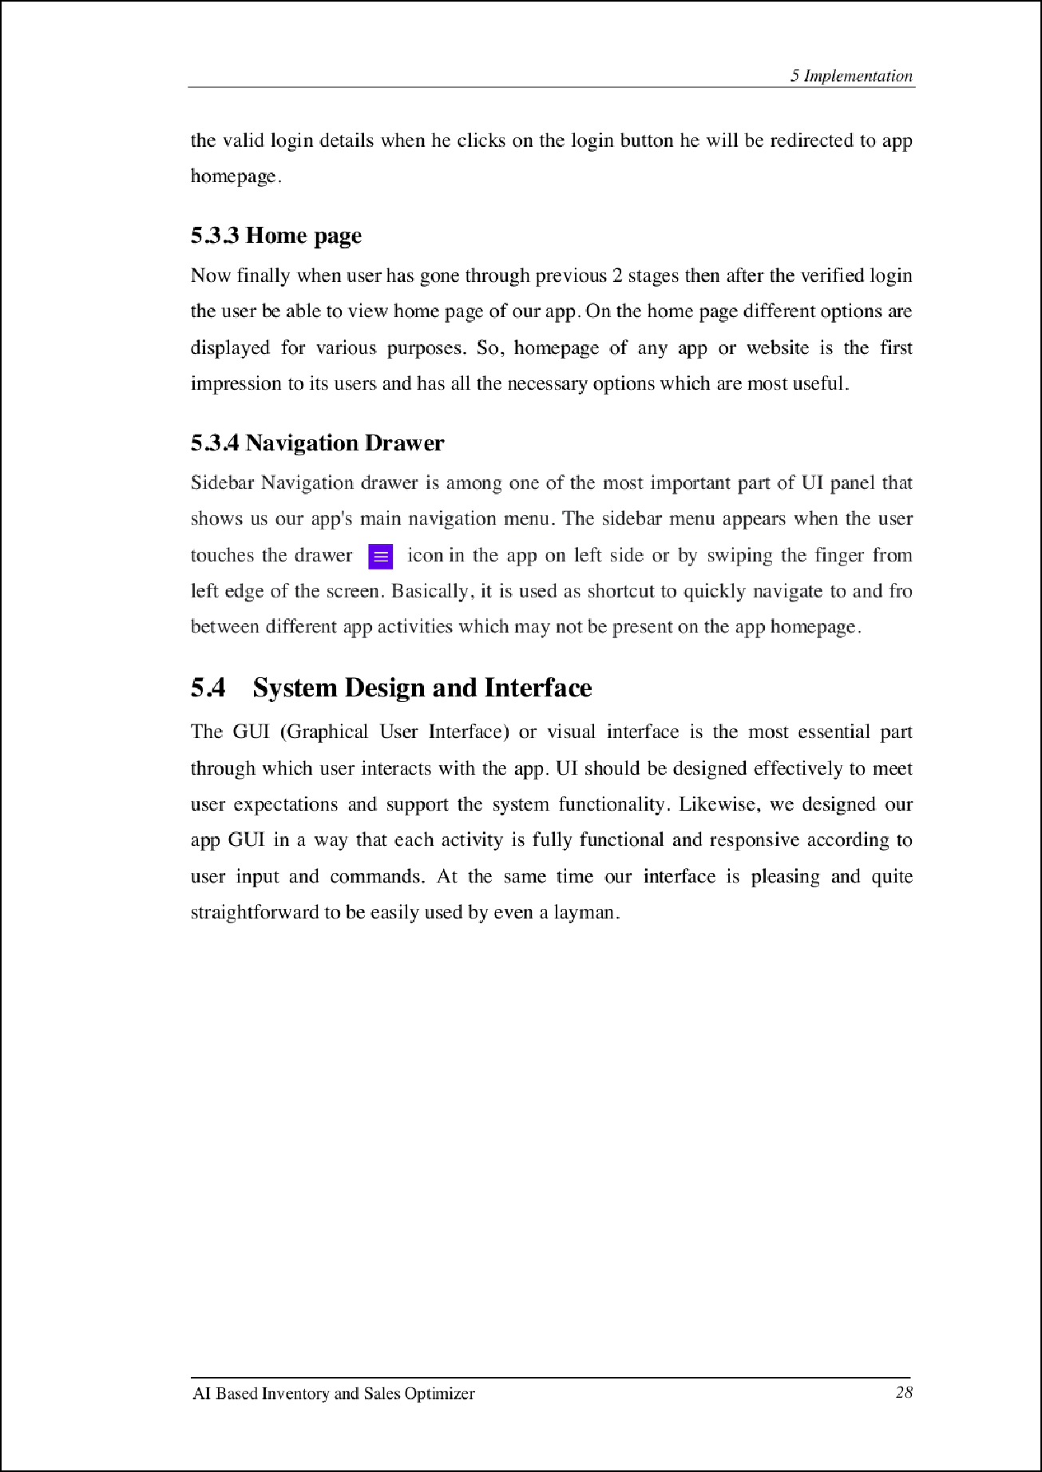

9

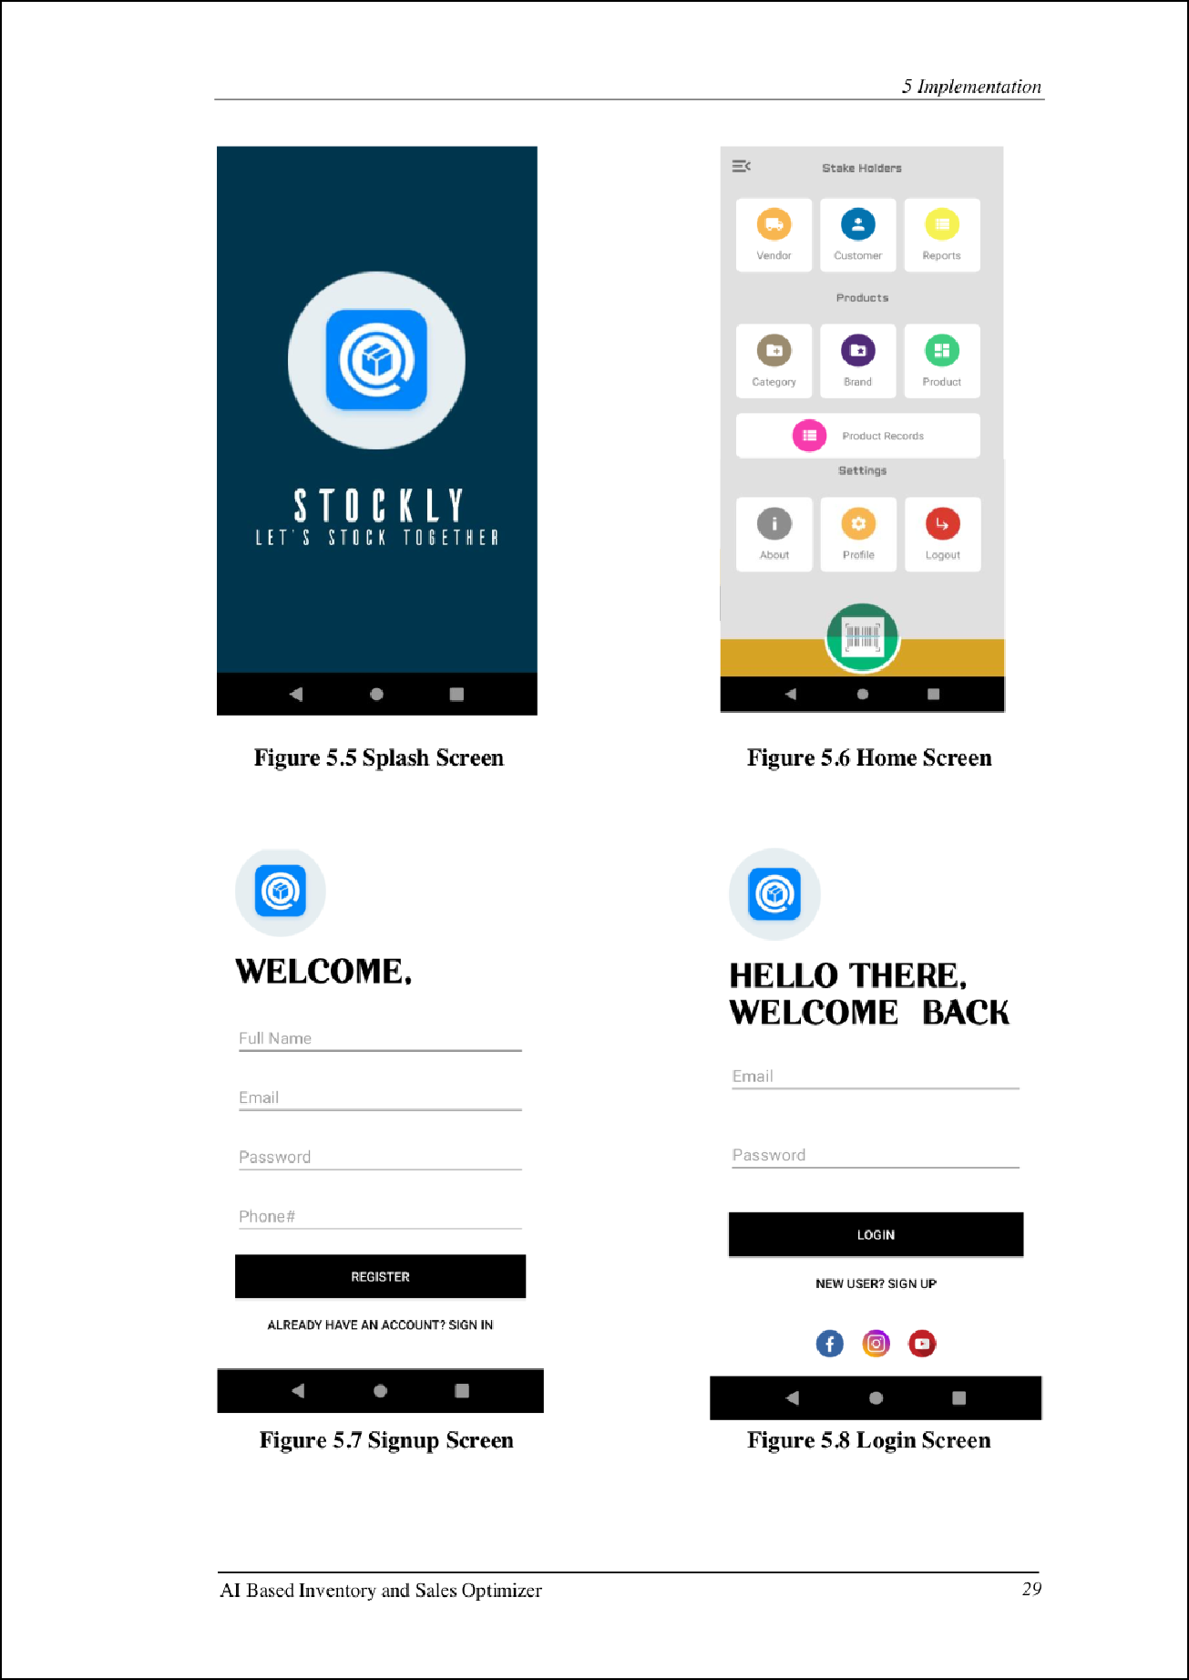

18

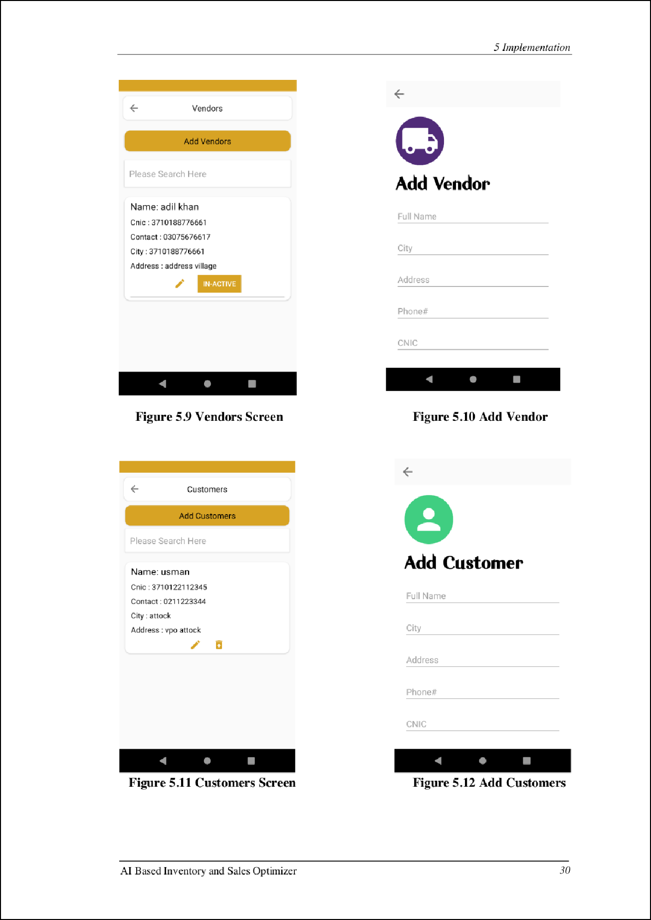

10

*5 Im plementation*

f- Reports

Please Select Month



**Figure** 5.13 **Reports Screen**

|  |  |  |
| --- | --- | --- |
|  | Add a new category  Category name here |  |
| EXIT ADD |



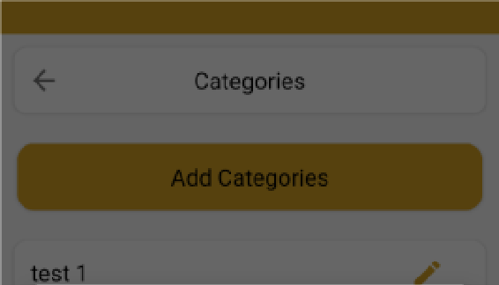**Figure 5.14 Add Products Category**

7 2 12 I

f- Brands

Add Brands

tes tb

Add new product

Select Categor,·

test 7

**Sele ct B,and:**



EXIT ADO



**Figur e 5.15 Add Products Brand F igure 5.16 Add Products info**

AJ Based Inve ntory and Sa les Optimize r *31*

*5 Im plementation*

Products

Please Search here

tes t

Oua nt il)I : 1q

Rs. 5CKl

**A** Home

**!5** Products

**!5** Out of Stock Products

·- Sugg ested Products

I■ Predicted Sale

iii Category

iii **Brand**

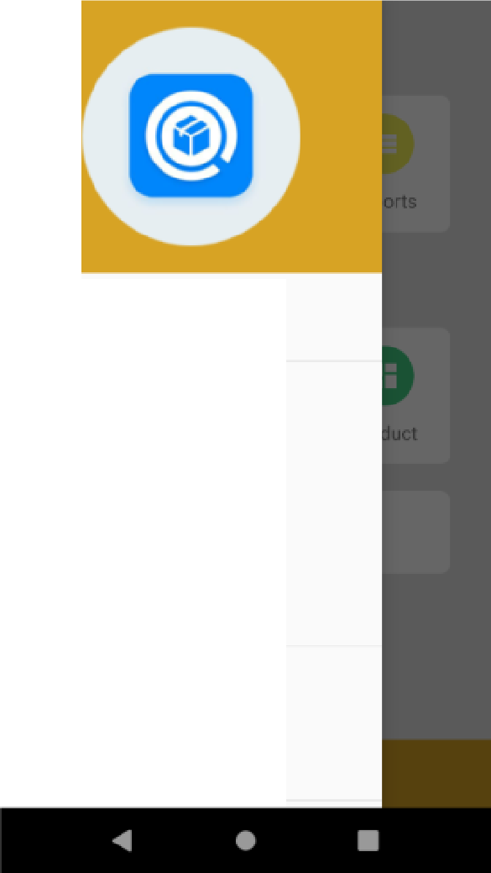



**Figure 5.17 Products Screeen Figure 5.18 avigation bar**

Profile Informat ion



Name""

Adeel ahm ed

Em ail*

d a'Tlail c.or1

Phoneir

03490565797

Shop Name*

adeels

Address *



**Figure 5.19 User Profile**

AJ Based Inve ntory and Sa les Optimizer *32*

###### Chapter 6 Evaluation and Testing

33

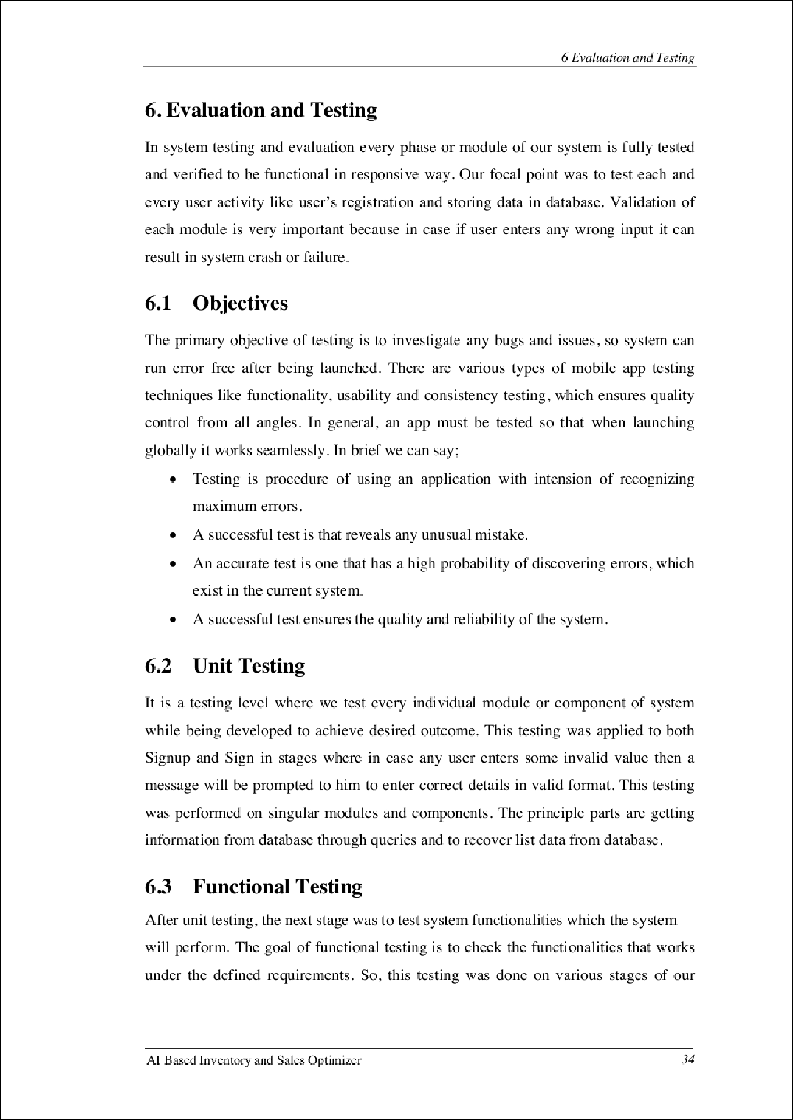

19 19

*6 E11a /uatio 11 and Testin g*

app, e.g sign up & log in , check records, send request, view orders history etc to verify tha t the y are functional in a proper way.

* 1. **System Testing**

We just fully focused on acc ur ate tes tin g of the system throug hout the design and imp le ment ation phase whi le tes tin g the shop owner and vendor ac tivi tie s that the y perform and storin g or retr ie val of data from dat abase . This evaluation was done for tes tin g each and every module of the system and to spot the errors which occur with the database or ap p interface.

* 1. Test Cases

|  |  |  |  |
| --- | --- | --- | --- |
| **Steps** | **Action** I **Expected Result** | **Actual Result** | **P/F** |
| **1** | Phone started App lic ation will not  I start | Applic at ion is not  launc hed | p |
| **2** | Phone menu ' App lica tion icon will  opened I be d isplayed | fcon displayed in  phone menu | p |

I

**Table 6.1: Test Case** - **Appl jca tion Start**

**1** Sign up I

**Expected Result**

**Action**

**Steps**

Account created

Account created

I

**P/F**

**Actual Result**

I

p

p

- **2** - -

f-

3

-- succ es sfull y - - -

Enter Logi n Session logged in User directed to details -- app after login

Press login or Data wi ll be sent to or Data is stored or

signu p button retrieved from database retrieved from p

database -

**Table 6.2: Test Case** - **User Login/ Sign Up**

AJ Based Invent ory and Sales Optimizer *35*

*6 E11a /uatio 11 and Testin g*

|  |  |  |  |  |  |  |  |
| --- | --- | --- | --- | --- | --- | --- | --- |
| **Steps** | **Action** | | **Expected Result** | | **Actual Result** | I  **P/F**  I | |
| 1 | lnsert  i nformation | I | | Information disp layed in database and web  se rvice | Informa tion displayed | p |  |
|  | Check  i nformat ion | I  I | | Information wi ll entered into right fie ld s as it is | In forma tion |  |  |
| 2 | entered i nto the | p |
|  | right fields as it is |  |
|  | e ntered |  |

**Table 6.3: T est Case** - **Data Store**

I

**Actual Result**

I

**Steps**

**P/F**

**Expected Result**

**Action**

I

Sign in to the Successfully sign in to

I

p

Signed in succe ssfu ll y to

driver appl ic ation

driver application

I

applic ation

Display use r Successfully show use r

2

1. Add inventory ' Products should be

p

User in ter face is displayed

succ es sfull y

interface

I

interface

Products added to database

Product s added p succ es sfull y

1. Add customers Vendo rs/c ustomers and vendors data shou ld be added

-

- View stock Database produc ts

5

produc ts should be disp layed

Vendo rs/customers p

dat a added

-

--

Products were p

visible to user

6

Items sold and stats were visible

View sales ' His tory of ite ms and

record and report stats shoul d be visible

p

7

# - --

p

View mos t ' Most sellin g item

-

-

p

-

sellin g i tem s should be visible

**8** Log ou t fr om the Log out succe ssfull y -

Successfully

loggedou t

applic ation from the applic at ion

**Table 6.4: Test Case** - **Shop Owner Module**

-

Items sold mostly

were visible

AJ Based Inve ntory and Sales Optimizer *36*

*6 E11a /uatio 11 and Testin g*

-

|  |  |  |  |  |
| --- | --- | --- | --- | --- |
| **Steps** | **Action r** | **Expected Result** | **Actual Result** | **P/F** |
| **1** | Check for shop  owne r orders | To view the orders li s t  from the shop owners | Vendor can view  shop owner orders | **p** |
| **2** | Log ou t from the ap plic ation | Log out successfully  from the app li c at ion  -- | Successfully logged out | **p** |

I

**T able 6.5: Test Case - Vendor Module**

AJ Based Inve ntory and Sales Optimize r *37*

Chapter 7 Conclusion and Future Work

38

7 *Conclusion and Future Work*

1. Conclusions and Future Work

**"Al** Based Inventory and Sale s Optimj zer" Android app will be a grea t bless i ng for shopkee pers or warehouse owne rs who will not be able to simp ly track and maintain a record of their daily sales or purcha se activities, but also will be ab le to keep the in ven tory updated wi th the latest items whic h are mostly sold or i n whic h use rs are mostly i nterested to bu y them and to forecast the amo u nt of sale i tems in coming time th rough the use of **Al.** This applic atio n will be best suit ab le to be used by shops or small-sca le business owners beca use the system wi ll ove rcom e their daily routine problems whic h are bei ng faced by these people dur in g their wo rk.

* 1. Future Work

There could be couple of changes possible in future whic h wo u ld make the system handie r and more use ful. Some planed future i mpleme ntatio ns are mentioned below,

* Local payment gateways impl antation within the app like Jazzcash.
* The iOS platform version for this app may be planned in near future.
* Pu bli s hin g this app to popular app stores so max people can excess it across the glo be.
* Suggestions and recommenda tion algorithm to made more precise to acc ur ately predict the products which are mostly sold out.
* Customer mod ule can be also considered to be an add i tion in current syste m.

AJ Based Invent ory and Sales Optimizer *39*

**Appendix A**

List of Reference Variables

[ I ] http ://www.co lurnb ia.ed u/cu/computin ghistory/ho llerith .html

[2] https: //www .waspbarcode.com /b uz z/how -barcode -scann ers -wo rk (3 https: //en.wi kipedia.org /wiki/Inve ntory_manage men t_software

https: // I000projects.org/projects/andro id-projects/page/5

http s://play .goog le .co m/store /app s/details?i d=com.kutir so ft.dailysalesrecord https ://play .google .com/sto re/apps/de tails?id =my.aahmetbas.stockcontro ller https://ieee xp lo re.ieee.org /documen t/9074234

https: //bidhee .com /produc ts/inve ntory - manage ment -sys tem

https: //www .nets uite .com/ porta l/ reso urce /art icles/in ven tory management

/inventory-manage ment-syste m-features .shtml

40

Ai based Inventory

15

ORIGINALITY REPORT

#### %

SIMILARITY INDEX

10%

INTERNET SOURCES

1%

PUBLICATIONS

10%

STUDENT PAPERS

PRIMARY SOURCES

1 Submitted to Higher Education Commission Pakistan

Student Paper

[www.javatpoint.com](http://www.javatpoint.com/)

2

Internet Source

dspace.daﬀodilvarsity.edu.bd:8080

3

Internet Source

en.wikipedia.org

4

Internet Source

abhiandroid.com

5

Internet Source

appgrooves.com

6

Internet Source

[www.hostinger.co.uk](http://www.hostinger.co.uk/)

7

Internet Source

Submitted to University of Bedfordshire

8

Student Paper

developer.android.com

9

Internet Source

3%

2%

1%

1%

1%

1%

1%

<1%

<1%

### Submitted to University of Portsmouth

10

Student Paper

mix.poak.top

11

Internet Source

Submitted to Florida Community College at Jacksonville

12

Student Paper

Submitted to The University of Manchester

13

Student Paper

maﬁadoc.com

14

Internet Source

dspace.up.edu.ps

15

Internet Source

Submitted to Metropolia Ammattikorkeakoulu

16

Student Paper

[www.coursehero.com](http://www.coursehero.com/)

17

Internet Source

Submitted to De Montfort University

18

Student Paper

Submitted to Indian Institute of Information Technology, Design and Manufacturing - Kancheepuram

19

Student Paper

scholarbank.nus.edu.sg

20

Internet Source

<1%

<1%

<1%

<1%

<1%

<1%

<1%

<1%

<1%

<1%

<1%

21

22

23

24

25

26

27

28

29

30

Submitted to Kaplan University

Student Paper

Submitted to Laureate Education Inc.

Student Paper

Submitted to Napier University

Student Paper

Submitted to City University

Student Paper

Submitted to Asia Paciﬁc University College of Technology and Innovation (UCTI)

Student Paper

Submitted to Kolej Universiti Poly-Tech MARA

Student Paper

Submitted to University of Bahrain

Student Paper

docplayer.net

Internet Source

studylib.net

Internet Source

[www.mdpi.com](http://www.mdpi.com/)

Internet Source

<1%

<1%

<1%

<1%

<1%

<1%

<1%

<1%

<1%

<1%

Exclude quotes On Exclude matches < 10 words

Exclude bibliography On

Ai based Inventory

GRADEMARK REPORT

FINAL GRADE

/0

GENERAL COMMENTS

**Instructor**

PAGE 1

PAGE 2

PAGE 3

PAGE 4

PAGE 5

PAGE 6

PAGE 7

PAGE 8

PAGE 9

PAGE 10

PAGE 11

PAGE 12

PAGE 13

PAGE 14

PAGE 15

PAGE 16

PAGE 17

PAGE 18

PAGE 19

PAGE 20

PAGE 21

PAGE 22

PAGE 23

PAGE 24

PAGE 25

PAGE 26

PAGE 27

PAGE 28

PAGE 29

PAGE 30

PAGE 31

PAGE 32

PAGE 33

PAGE 34

PAGE 35

PAGE 36

PAGE 37

PAGE 38

PAGE 39

PAGE 40

PAGE 41

PAGE 42

PAGE 43

PAGE 44

PAGE 45

PAGE 46

PAGE 47

PAGE 48

PAGE 49

PAGE 50

PAGE 51

PAGE 52

PAGE 53

PAGE 54

PAGE 55